Kiel Russell

Lab 6

Task 1:

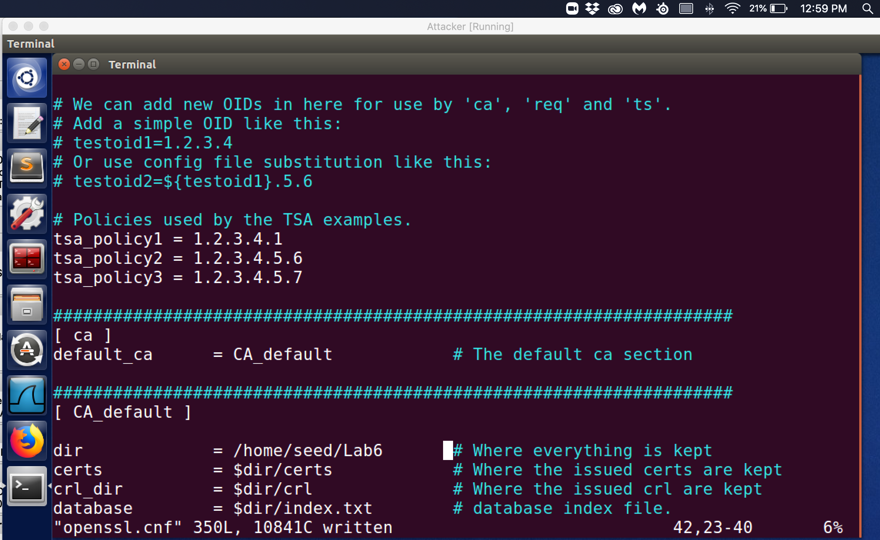

Observation: The initial directory for the certificate authority file “openssl.cnf” has been changed to the new directory to /home/seed/Lab6.

Explanation: In order for the certificate generation process to know where to locate my updated openssl.cnf file to know where to look I changed the dir field from the initial location to the the new directory that I created at /home/seed/Lab6 directory. This directory will now be used to create certificates and it was copied from the /usr/lib/ssl directory that comes with the original image.

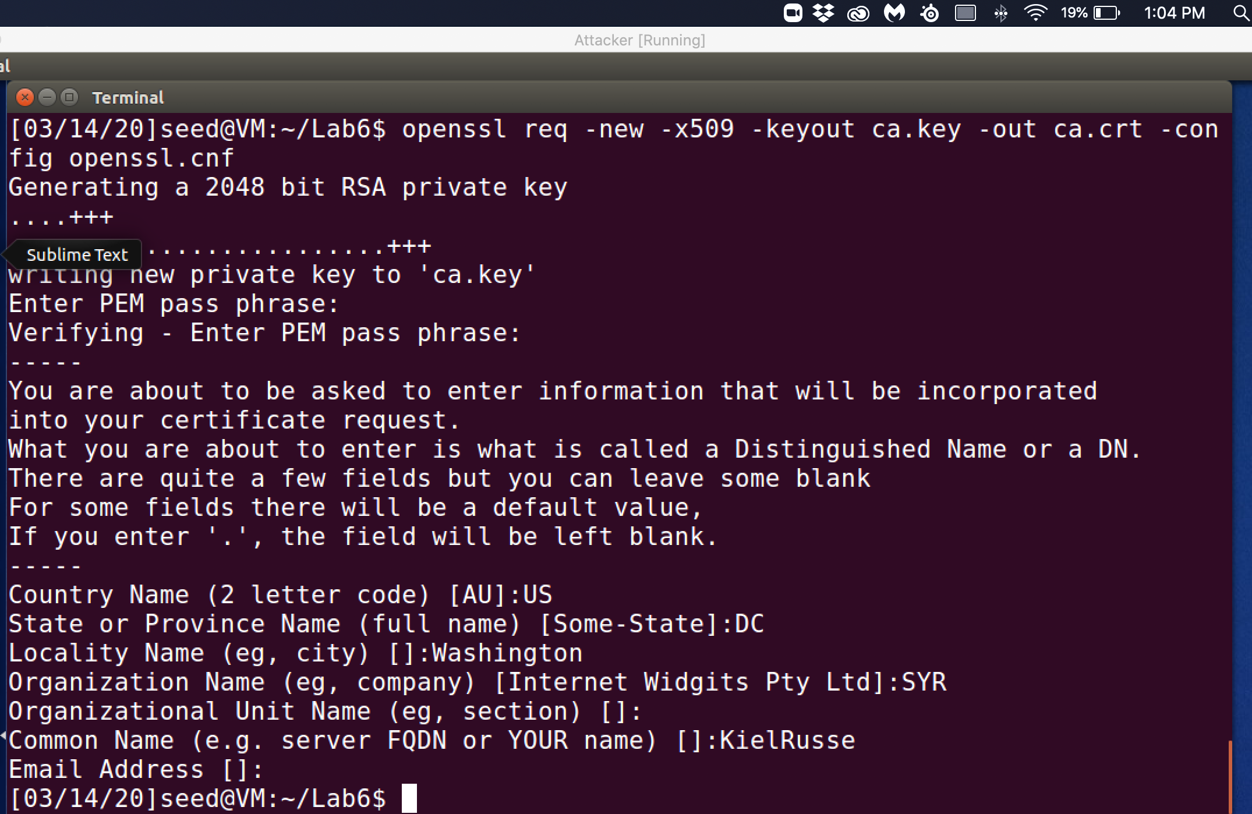

Observation: In order to generate a certificate I need to use the openssl command that contains multiple options to configure the certificate to the needs of the requestor from the available options. The options that were chosen for this task was “openssl req –new -x509 –keyout ca.key -out ca.crt -config openssl.cnf”. The certificate generator will request from the requestor a pass phrase so that when the file is attempted to be accessed within the directory that one last layer of security in the pass phrase is required by the user to access/modify the contents of the openssl.cnf file.

Explanation: “-new” is letting the certificate generator know that this is a new request. The “x509” option tells the certificate generator to make this a self-signed certificate and a CA certificate is that since we are not a certificate authority then the browser will throw an error if I tried to use a self-signed certificate between of the fact that as a non-certificate authority our identity cannot be verified. For demostration purposes though we are taking on the role of certificate authority within out testing sandbox. Root certificate authorities are the only users who can self-sign their own certificates because there identity has been verified by the official certificate authority. The ‘-keyout ca.key” option will tell the generator of the certificate to output the private key to the ca.key file show in the below screenshot. The private key is in an encrypted form as shown in the screenshot below. The “-out ca.crt” option tells the certificate generator to output the self signed certificate to the ca.crt file. The “-config openssl.cnf” tells the certificate generator where to find the configuration file that we put in the directory that I created. This is our redirect from the default image location of the config file in the /usr/lib/ssl directory to our new created directory /home/seed/Lab6.

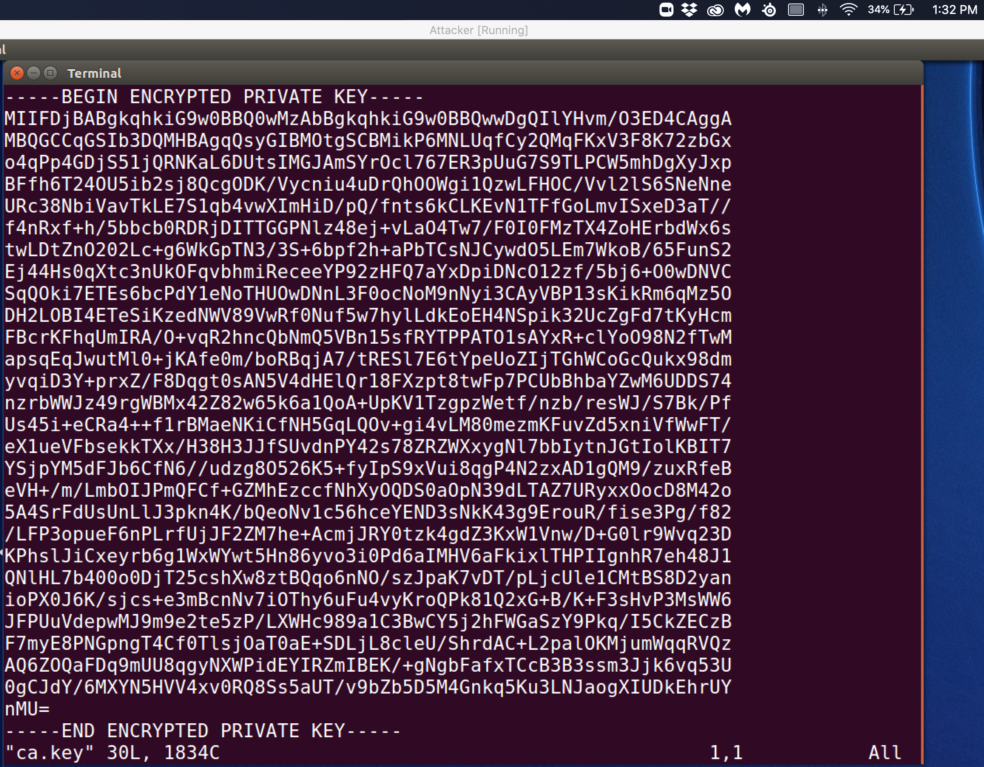

Observation: Here is a copy of the encrypted private key in the “ca.key” file.

Explanation: The “ca.key” file contains our fictional certificate authority private key that will be encrypted to ensure the security of the key. In order to use the private key, we must have the passcode to decrypt the private key so that it can be applied. This unencrypted private key is utilized to self- sign our own CA certificate which would be the function of an authentic root certificate authority. The way that this operates is that the private key will be used when requested and the public key that is located in the CA certificate that we generated will verify identity of other users and that verification will be forwarded to other entities.

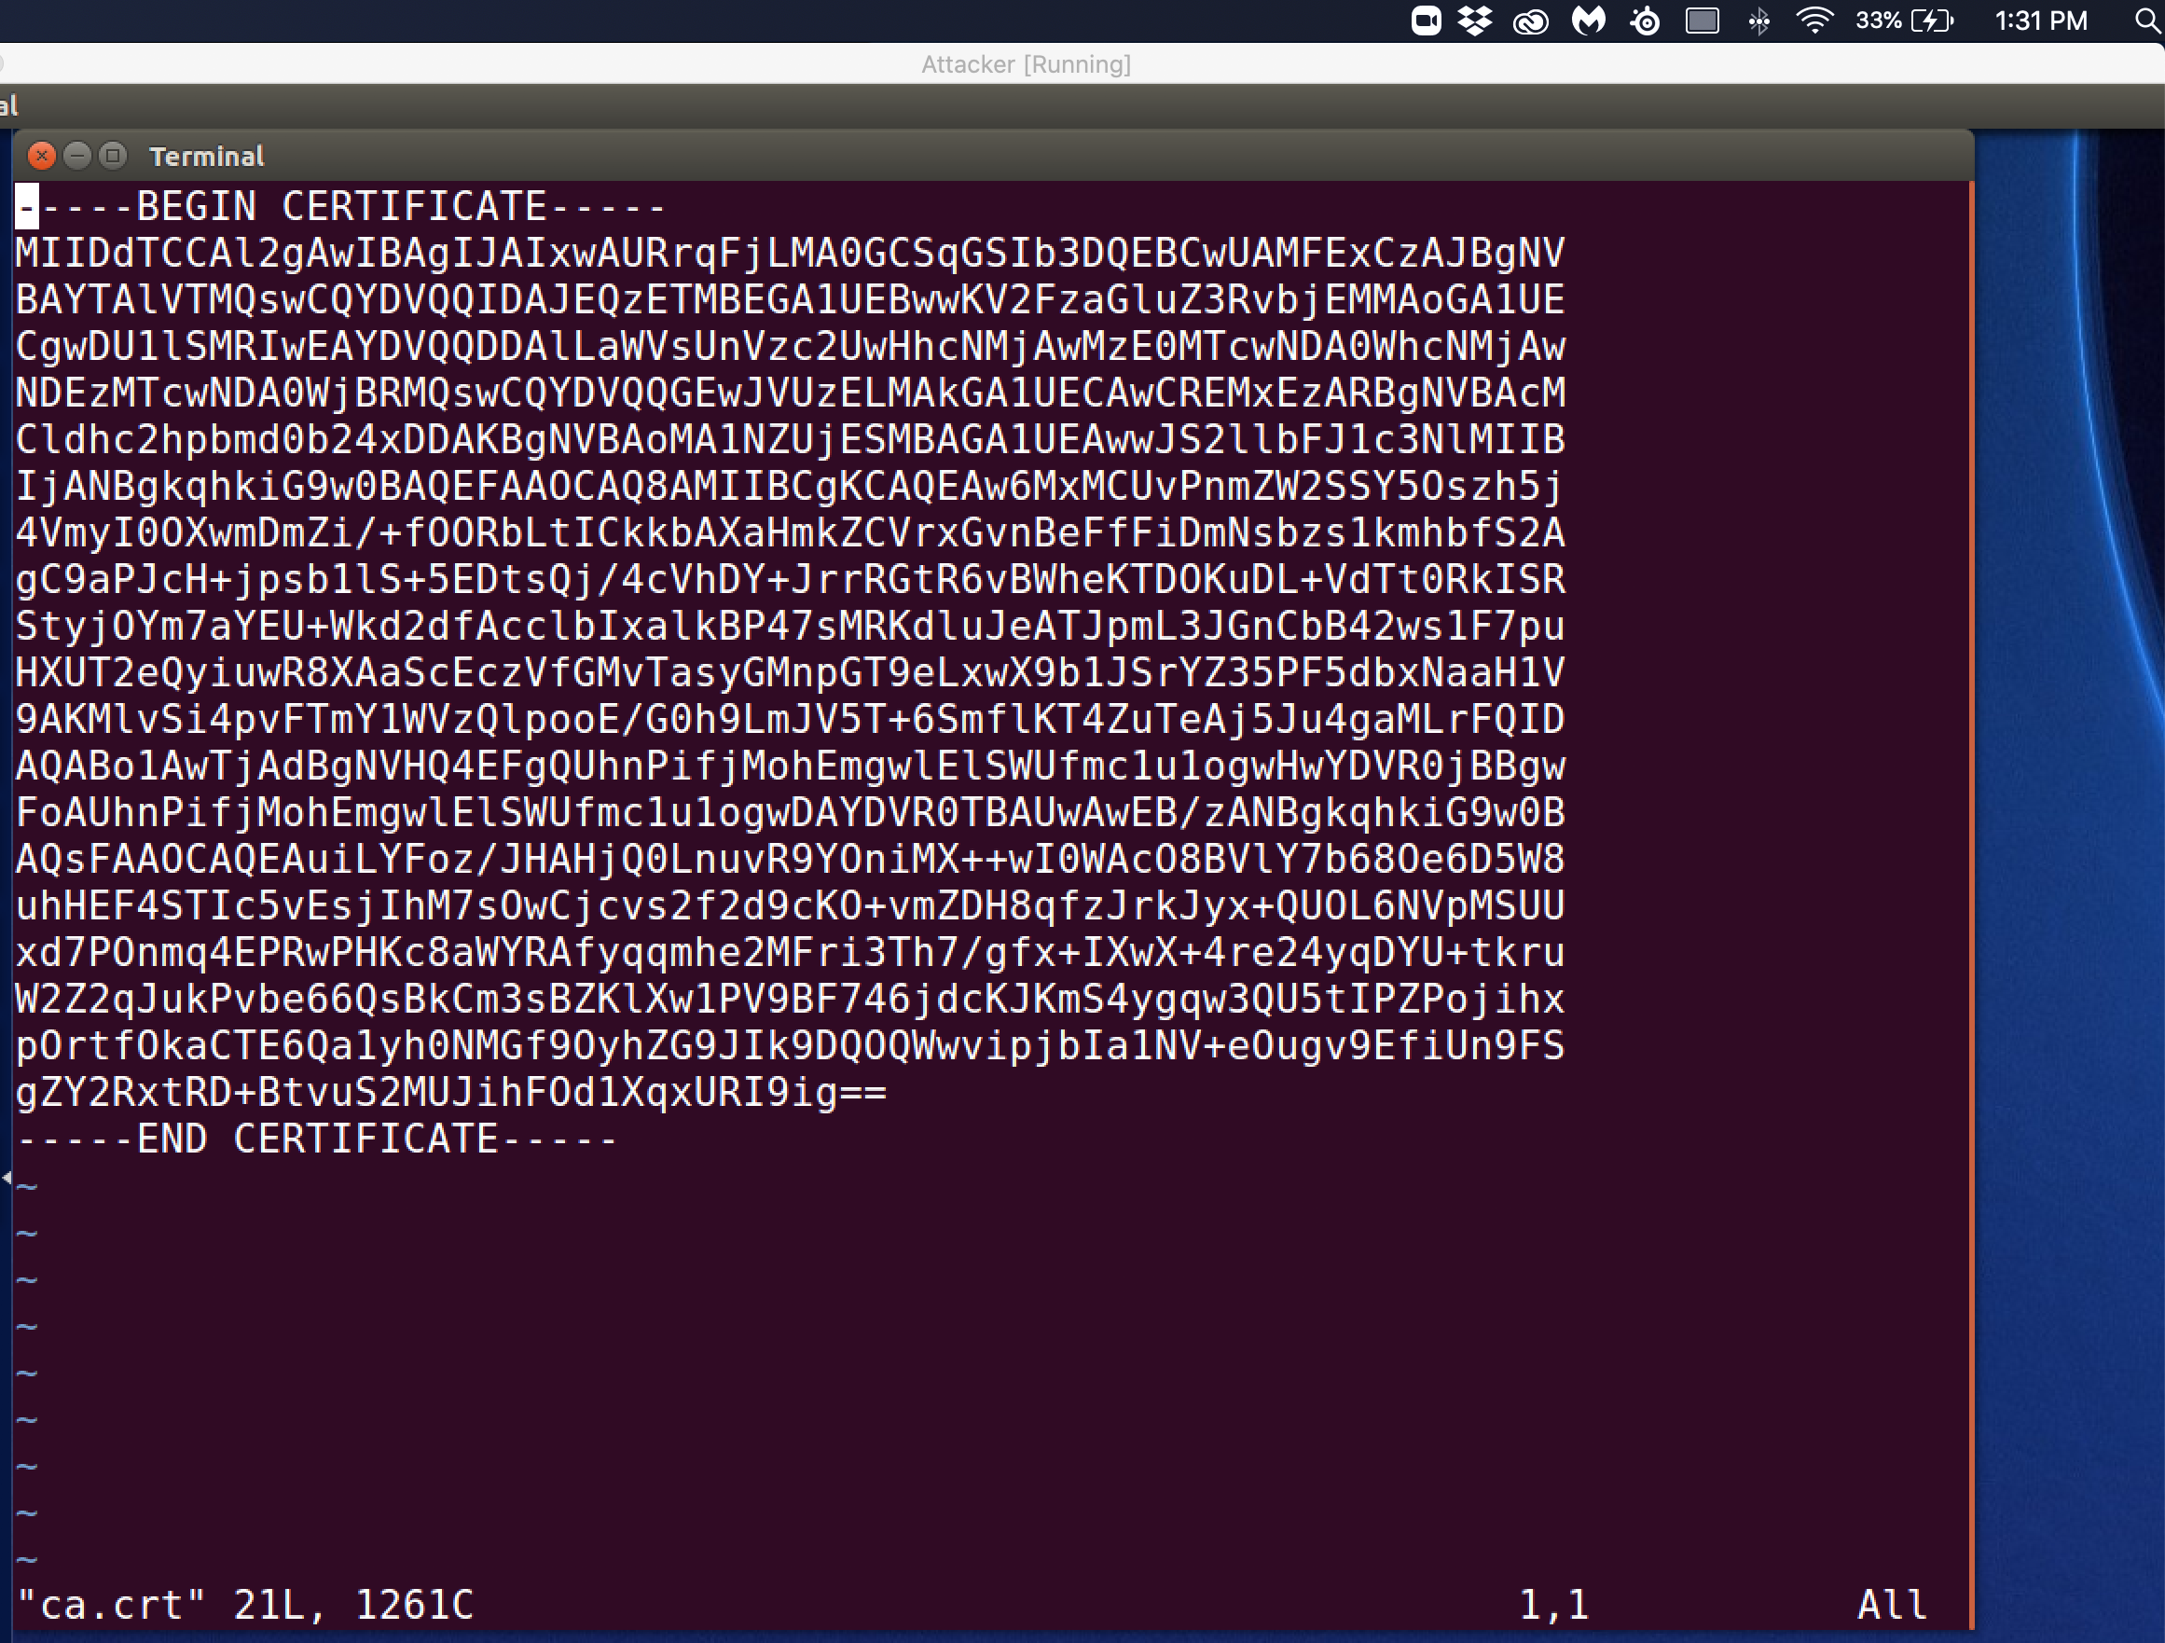

Explanation: For this lab we are acting as the certificate authority and redirected all future requests to sign certificate for different requestors to verify the identity of the requestor. In addition, to verifying the identity of requestors the CA will transmit the CA certificate is sent through secure means. In modern browsers there is a list of already verified certificate authorities and for this lab since we are taking the place of the CA our public key can be used to verify the authenticity of certificates that are signed by our test root certificate authority.

Task 2:

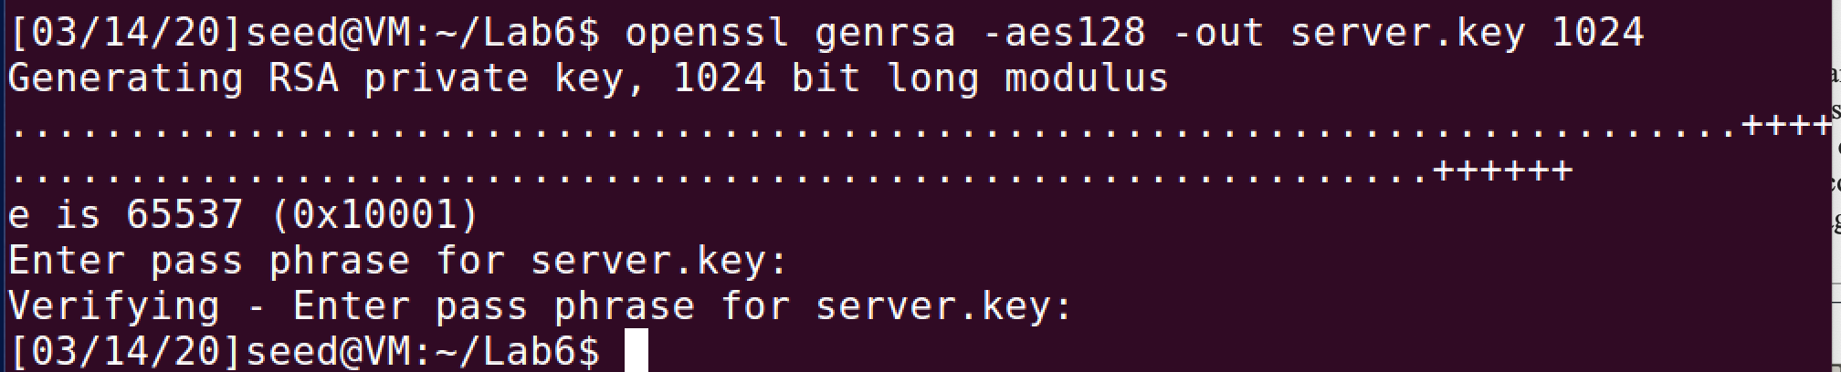

Observation: The requestor from SEEDPKILAB2018.com generates their public/private key pair through the command “openssl genrsa –aes –out server.key 1024”. I have included the password that I chose with the requested key.

Password is:turing

Explanation: The requestor from SEEDPKILab2018.com needs to generate a public/private key pair from the certificate authority that they will want to use to verify their identity with users who use our CA. They will then use that verification to request a x509 certificate from the CA. This utilizes the AES 128-bit encryption standard to create the key pair for the requestor.

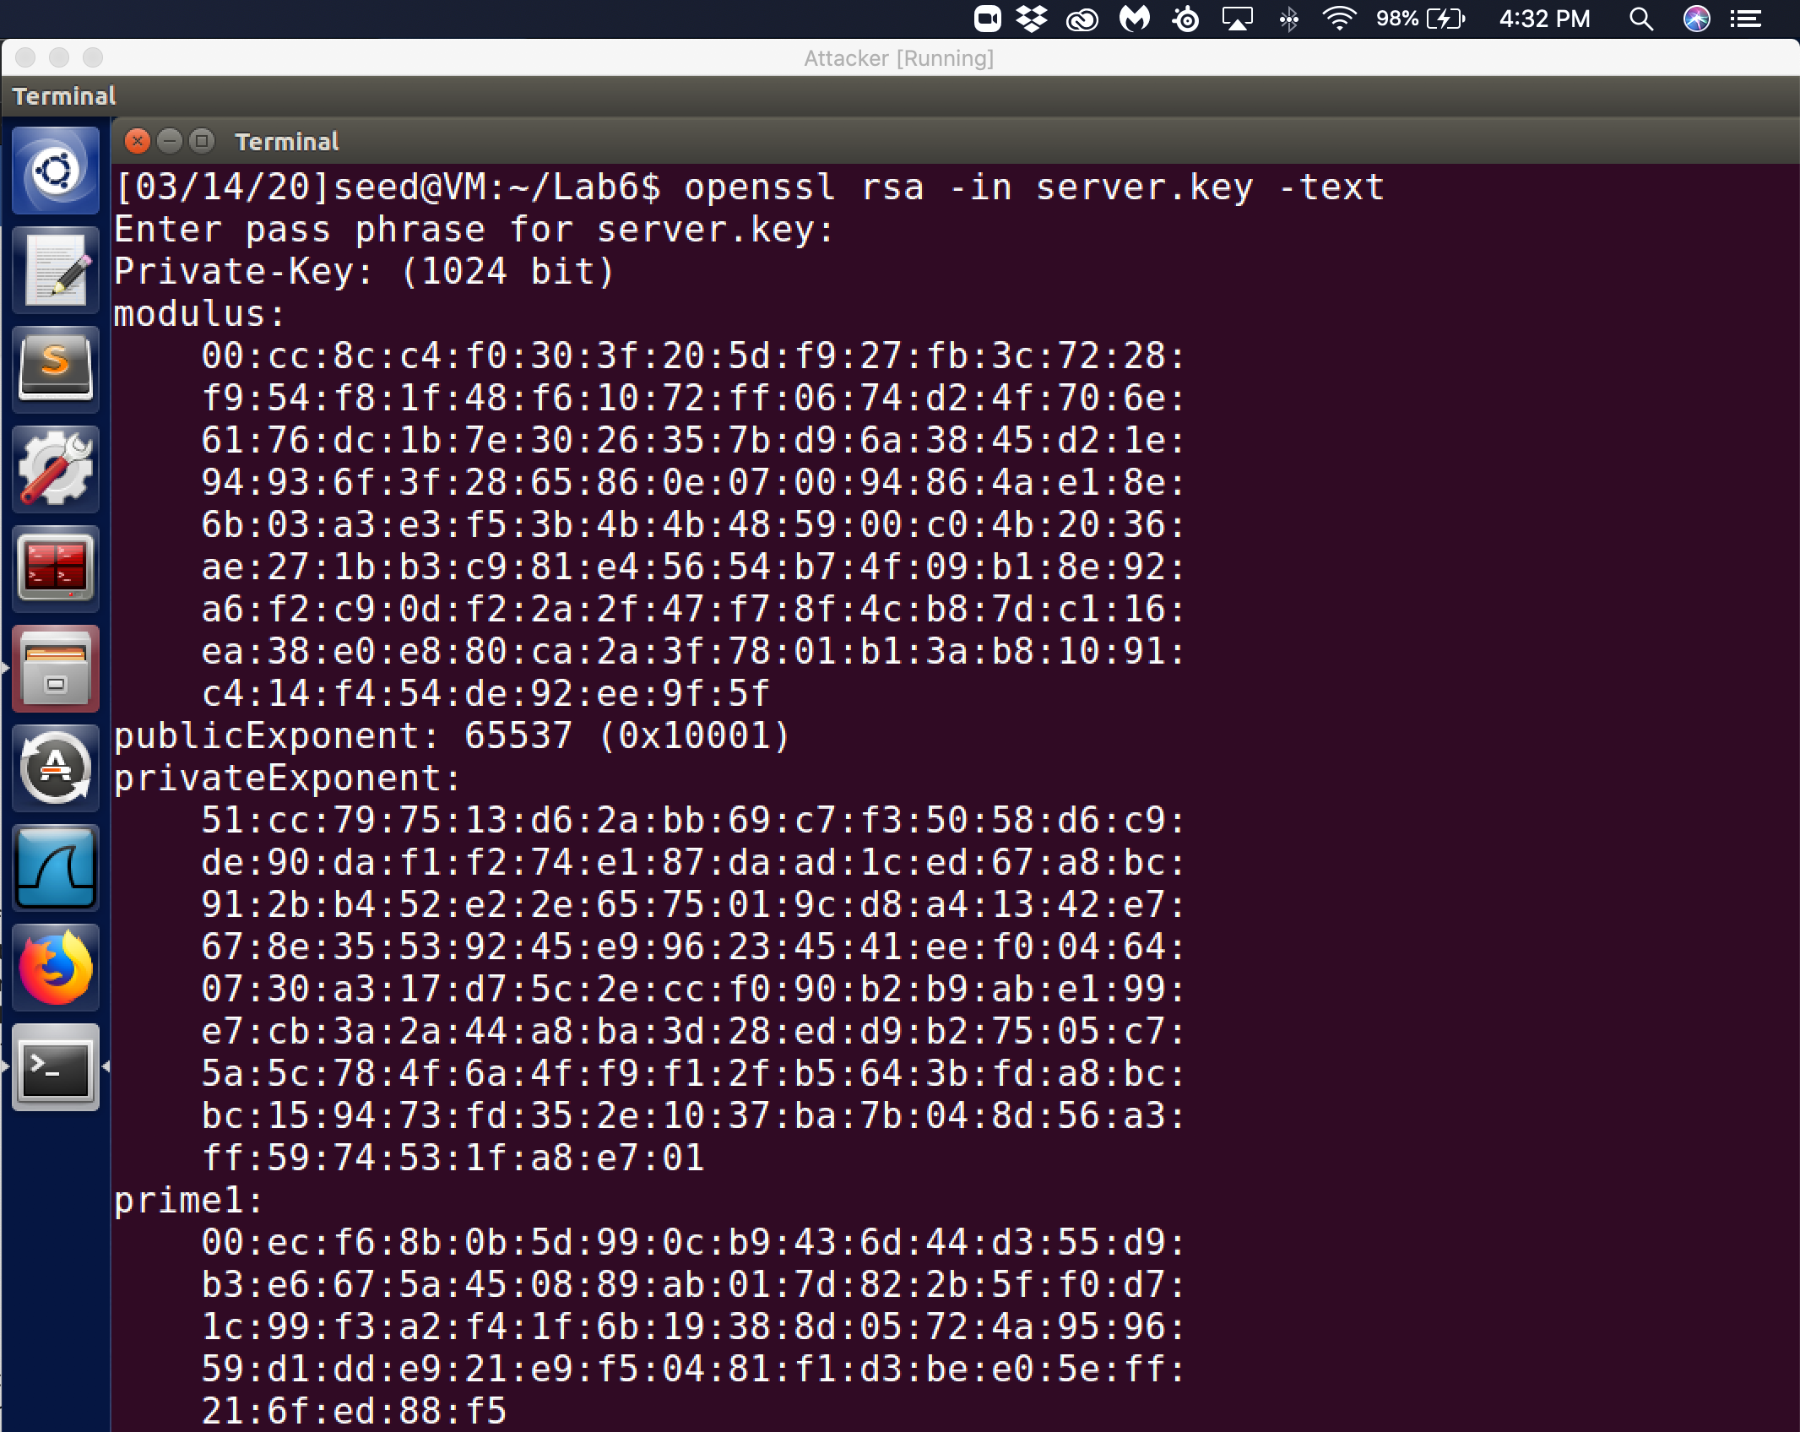

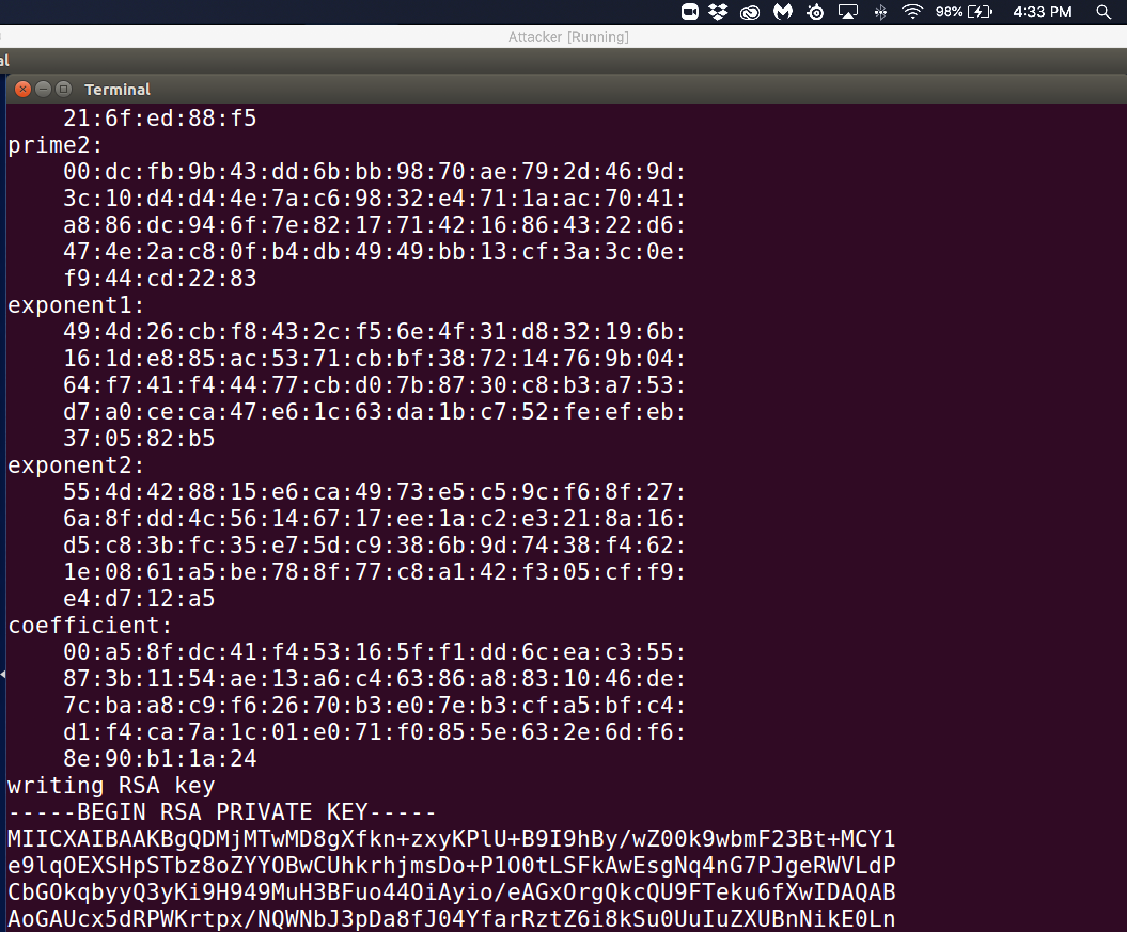

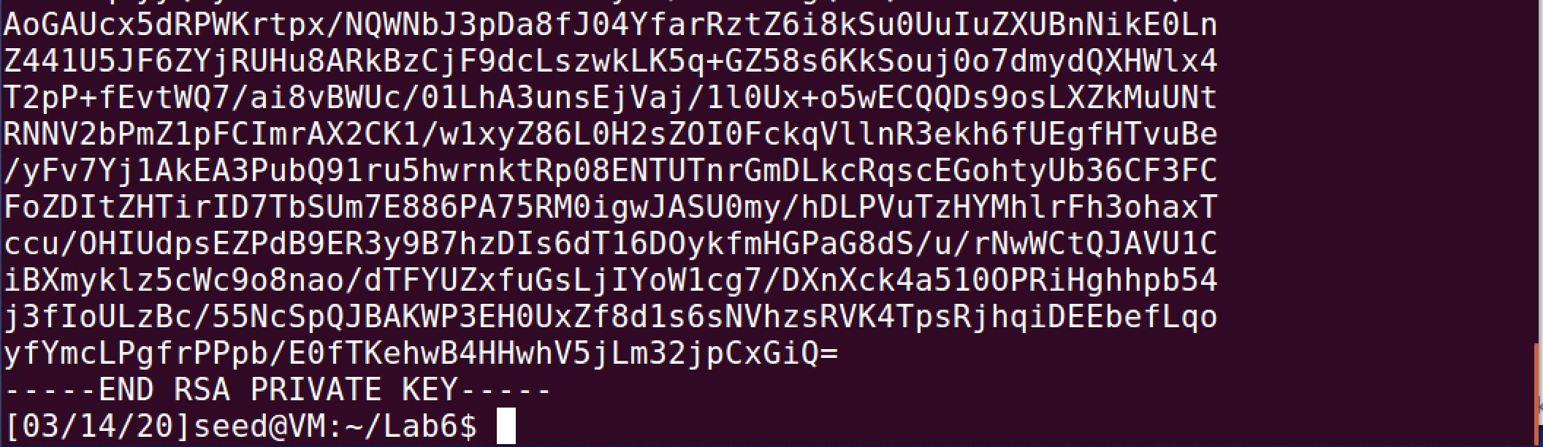

Observation: The above screenshots are of the contents of the server.key file that contains the public/private key pair along with the large primes, exponents, modulus, coefficient, and primes that make up the details of an RSA key.

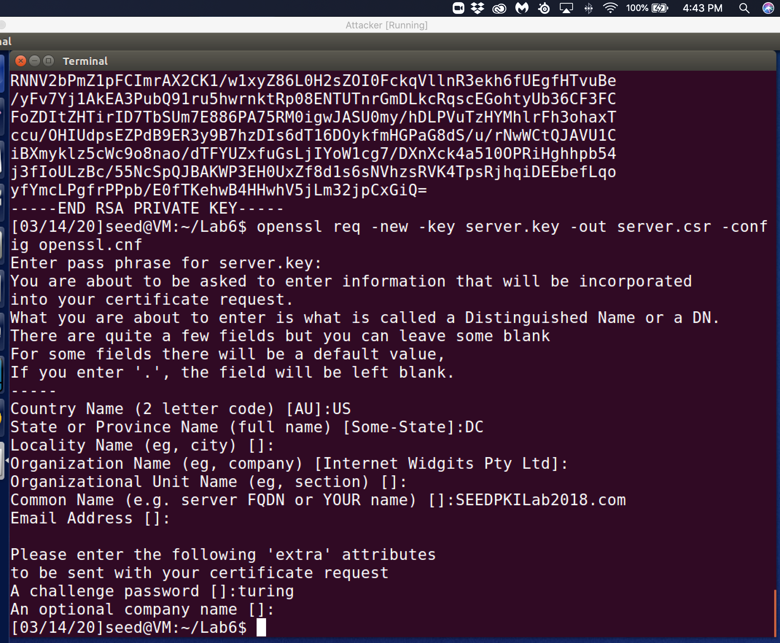

pass phrase = turing

Observation: Using the openssl command to request the generation of a certificate that will be send to our CA that we create to be validated and sign. The input that is used is the file that we created server.key that contains our public/private key pair that was created for the requesting site SEEDPKILab2018. When the encryption was ready to be completed a password was requested so that the certificate generating authority would verify before decrypting the files to use the contents inside.

Explanation: The requestor from SEEDPKILab2018.com generates their public/private key pair from our CA that results in them receiving a certificate. The requestor includes their server.key file that has their public/private key pair that is associated with their website. The resulting file is the server.csr file that which is the result of requesting a certificate from our fictional CA. The password used to encrypt the key pair file is required to decrypt the file to enable the contents to be forwarded to the CA for the certificate request. The requestor will then use the private key from the public/private key pair for the website SEEDPKILab2018.com is then utilized to sign the certificate request. Our fictional CA will verify the signature of the requestor with the public key of the request. This check will be the verification that the public key is from the requestor. This is how the assymetric key encryption policy works because it enables the requestor to keep hackers from creating fake certificate to try and inject the public key of the authenticated user into a new request to the CA because the CA will be able to distinguish that the public key from the requestor is not authentic.

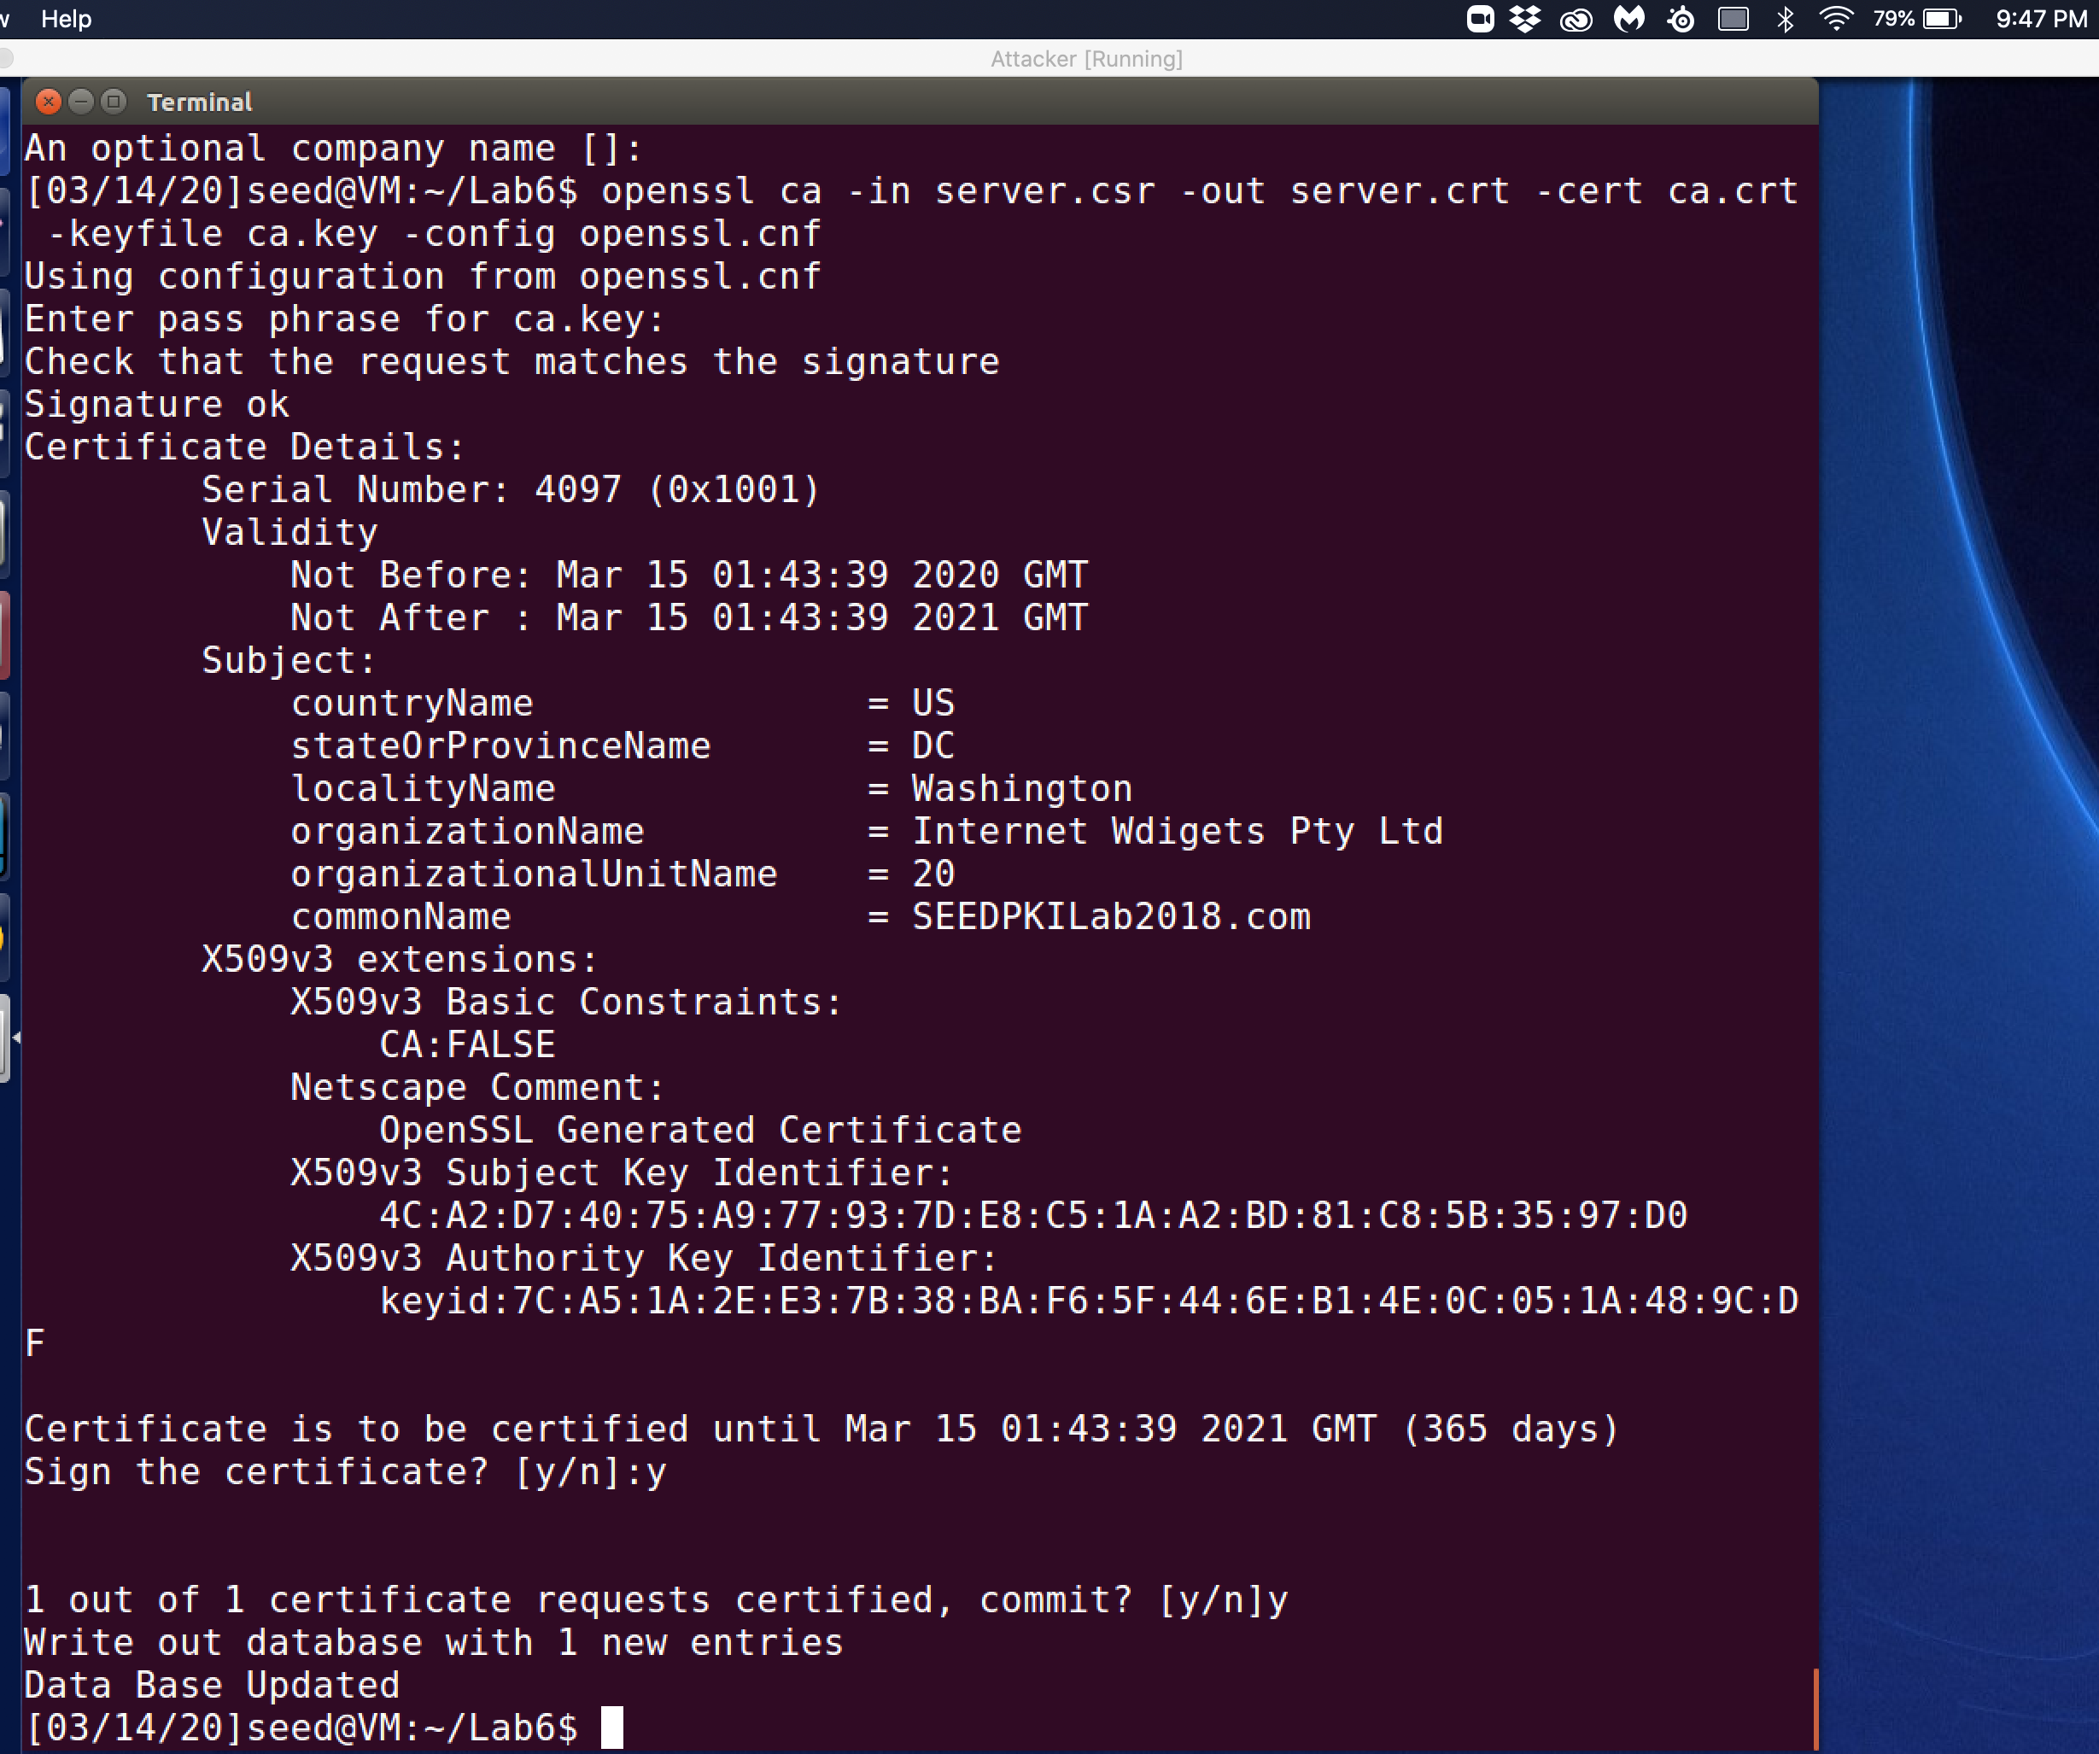

Observation: I was initially receiving errors and had to clear out my folder and rerun all of the certificate steps. This step was able to work as long as the server.csr file is not corrupted which was my issue before. This steps involves us signing the certificate request as the certificate authority. Openssl is how we sign the certificate request. This is accomplished by using the following command “openssl ca –in server.csr -out server.crt -cert ca.crt -keyfile ca.key -config openssl.cnf”.

Explanation: Since we are acting as a fictitious certificate authority, we will assess each request and sign the certificate and certify them by committing them. Another requirement of the certificate authority is verifying the identity of the website common name but since this is just a test where we are creating the site SEEDPKILab2018.com ourselves. “-in server.csr” is the option that tells which certificate request file will be verified. “-out server.crt” is where the certificate file will be output upon the CA signing the certificate. “-cert ca.crt” is the certificate that is used by the CA that will be combined with the information from the requestor’s certificate to create a new x509 certificate that includes information from both. “-keyfile ca.key” represents the file that points to where the CA has their public/private key. The private key will be used by the CA to sign the certificate we are generating for the requestor. “ca.key” requests the pass phrase to access the encrypted file that we generated in previous step of the lab, the pass phrase is required to access the private key and decrypt the file. In order to locate the openssl.cnf file we used the config command to inform the certificate generating program where to locate the files it needs and where to output the resulting certificate. The signature and the public key of the requestor is combined when the certificate is generated. The public key is used to verify identity as well as check that the signature is valid. Once the public key is verify the signature in the certificate request, in this fictional exchange between me as the CA and the requestor, the website which is also me, and then the CA signs the new certificate. After two y commands to signing the certificate, certifying, and committing the certificate request for the SEEDPKILab2018.com the website can now use the certificate.

Task 3:

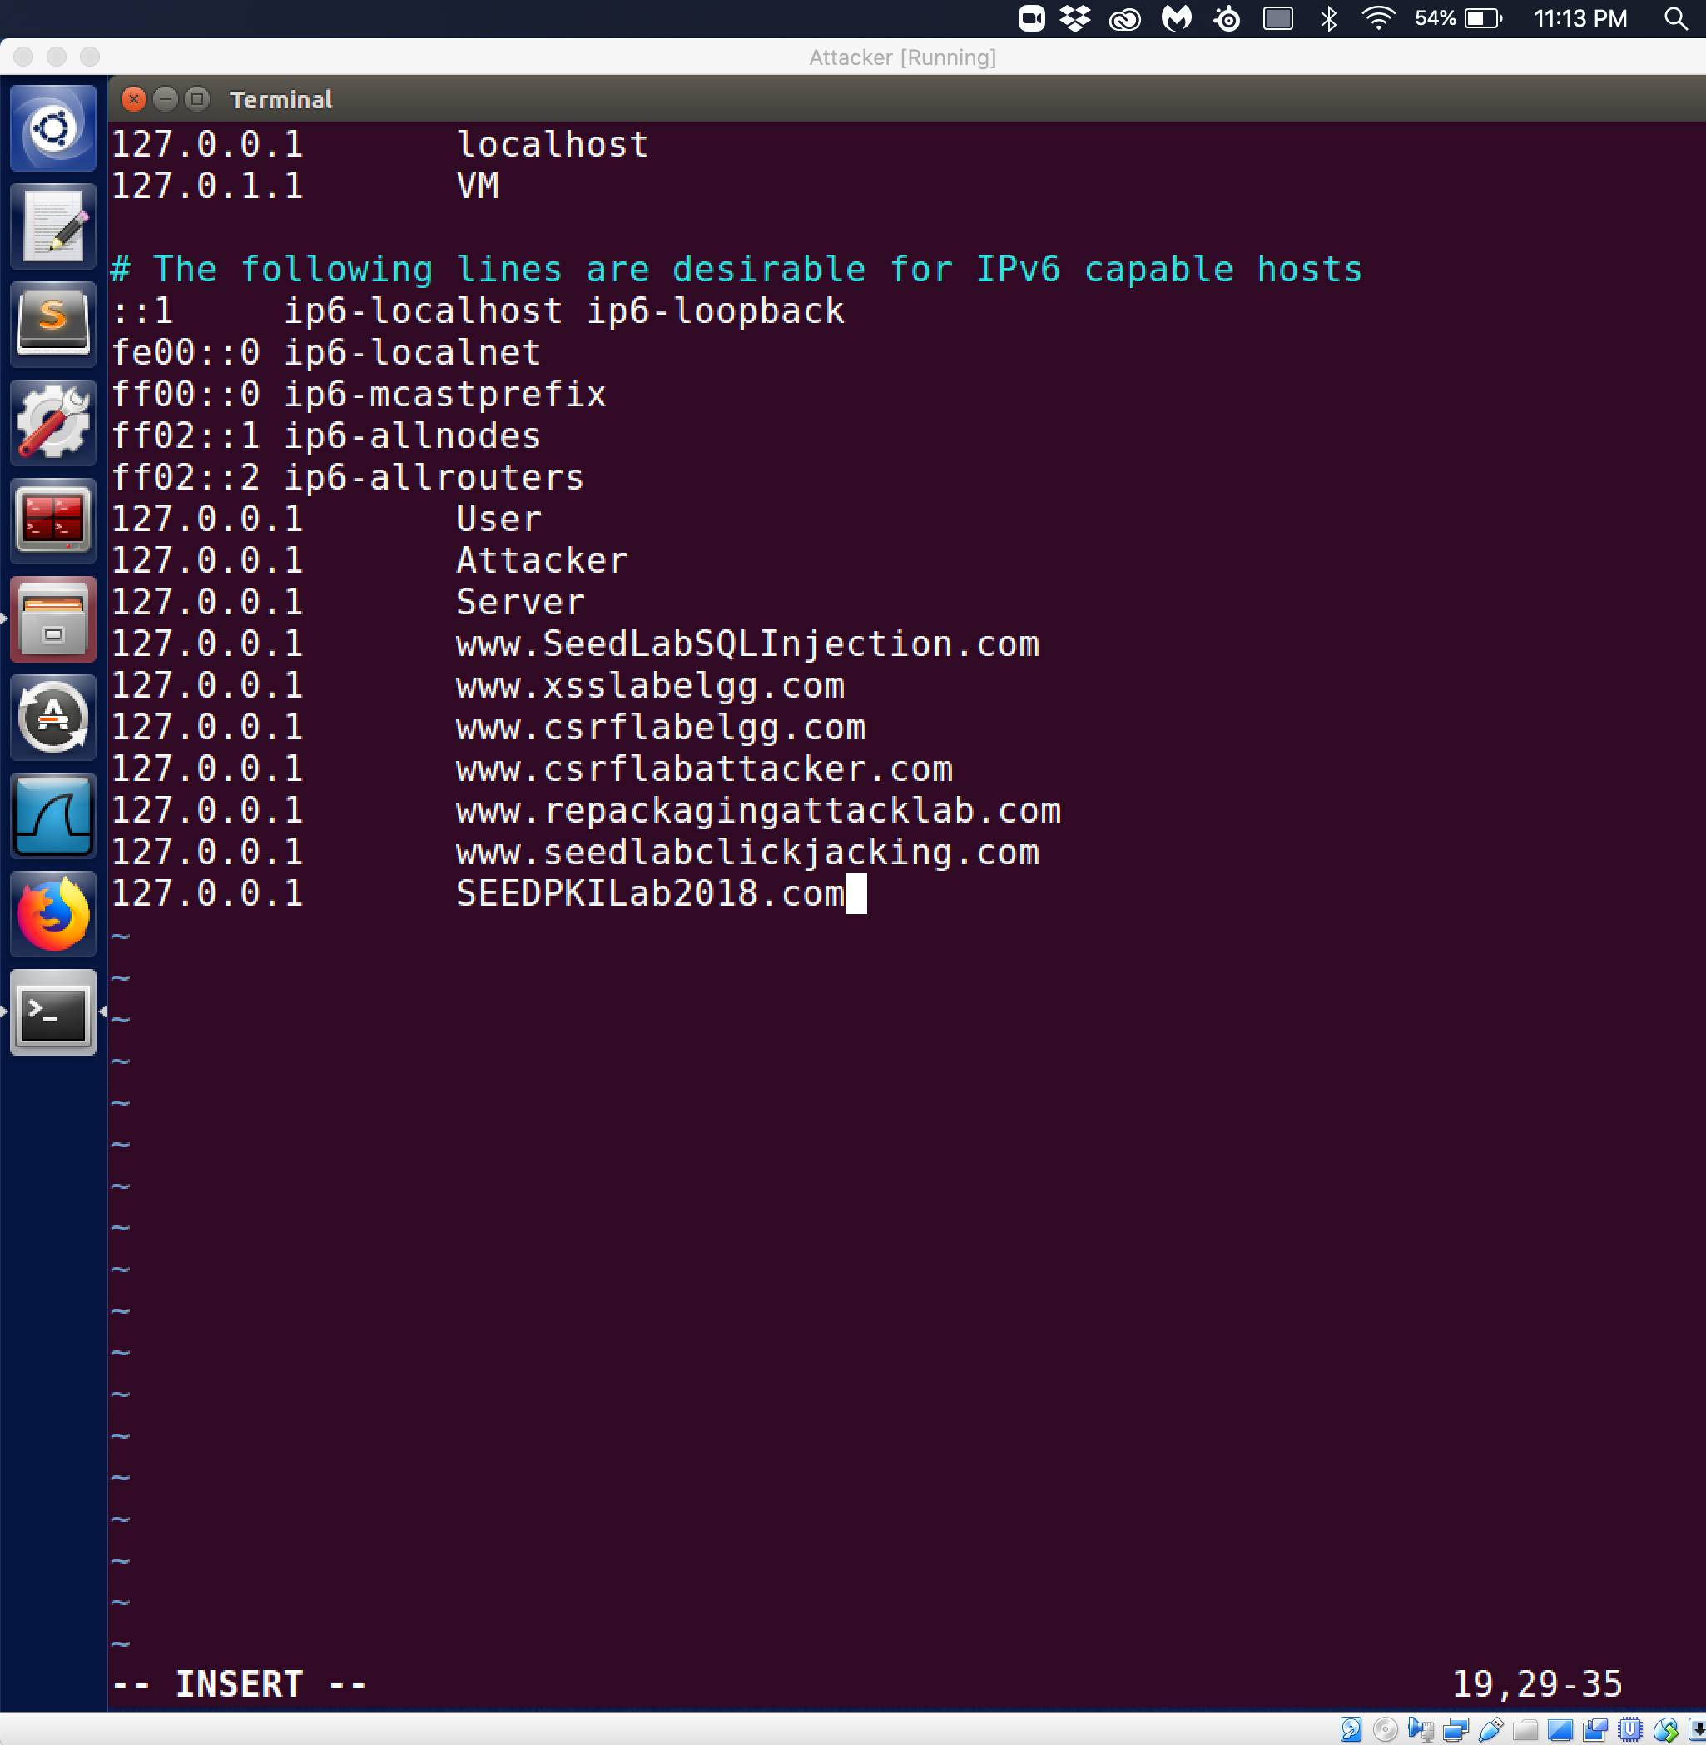

Observation: The above screenshot shows the entry for SEEDPKILab2018.com being added through “127.0.0.1 SEEDPKILAB2018.com” is added to the /etc/hosts file.

Explanation: Because SEEDPKILab2018.com only exists locally on this VM I want to redirect the browser to use the local VM IP address to access the website instead of the usual method of reaching out to a DNS server to resolve the ipaddress of the domain name. The above screenshot shows that entry being added to the hosts file.

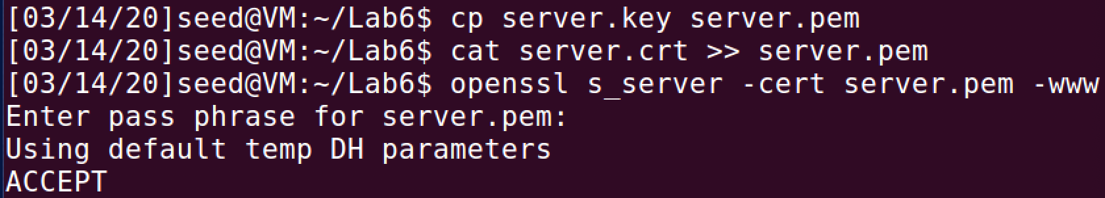

Observation: In order to prepare the key that was generate for use then the server key is combined with the server certificate through the cat command to append the server.crt file to the server.pem file. To start our experiment we use the openssl s_server that starts a web server with the certificate file that we just appended on the default port 4433.

Explanation: To enable the webserver to run we utilized the server.pem file which is the combination of the private key and the server certificate that will be used to decrypt information that is sent to the webserver and encrypt information using the public key. The webserver has a default listening port of 4433

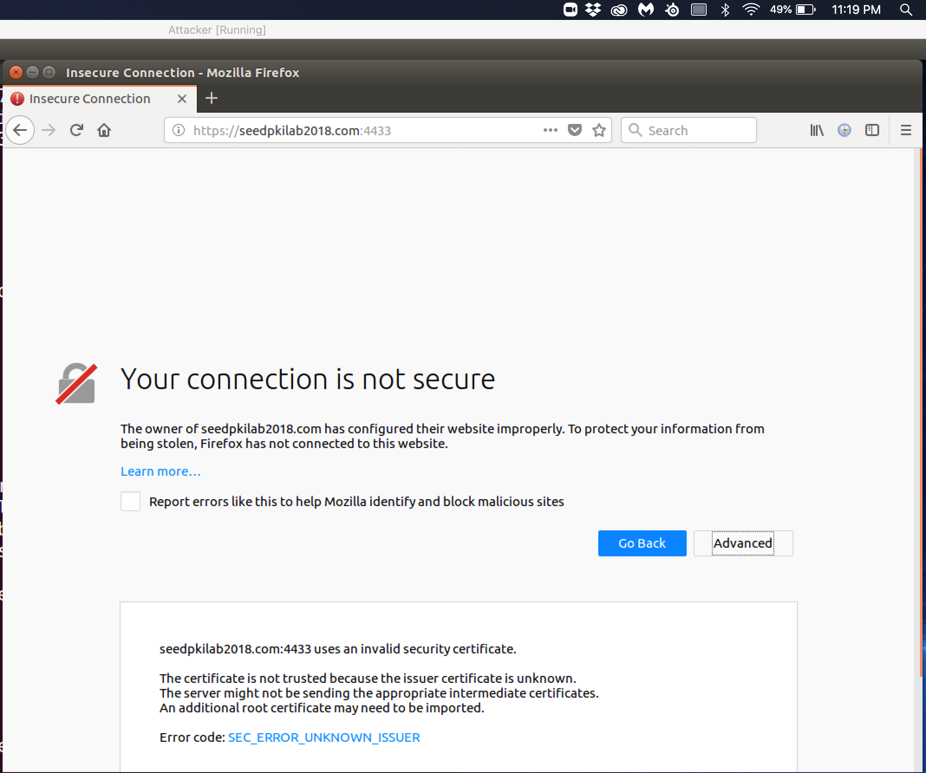

Observation: This is the first attempt to connect to the website through the port 4433 but because we are not an official CA then the message the certificate is not trusted because the issuer certificate is unknown to the browser because it is not in its CA authorities list.

Explanation: The connection to the website is not able to be completed because of the error code SEC_ERROR_UNKNOWN_ISSUER error because the certificate that is reference is not within the firefox browser’s preinstalled trusted root certificate authority certificate who are authorized to generate certificate because their identity has been verified. Therefore, in our next step we need to manually add our issuer certificate from our new role as a trusted certificate authority to the list of trusted certificates in the Firefox browser. This will let the Firefox browser to trust the certificate that we just added and will see the SEEDPKILab2018.com site as valid.

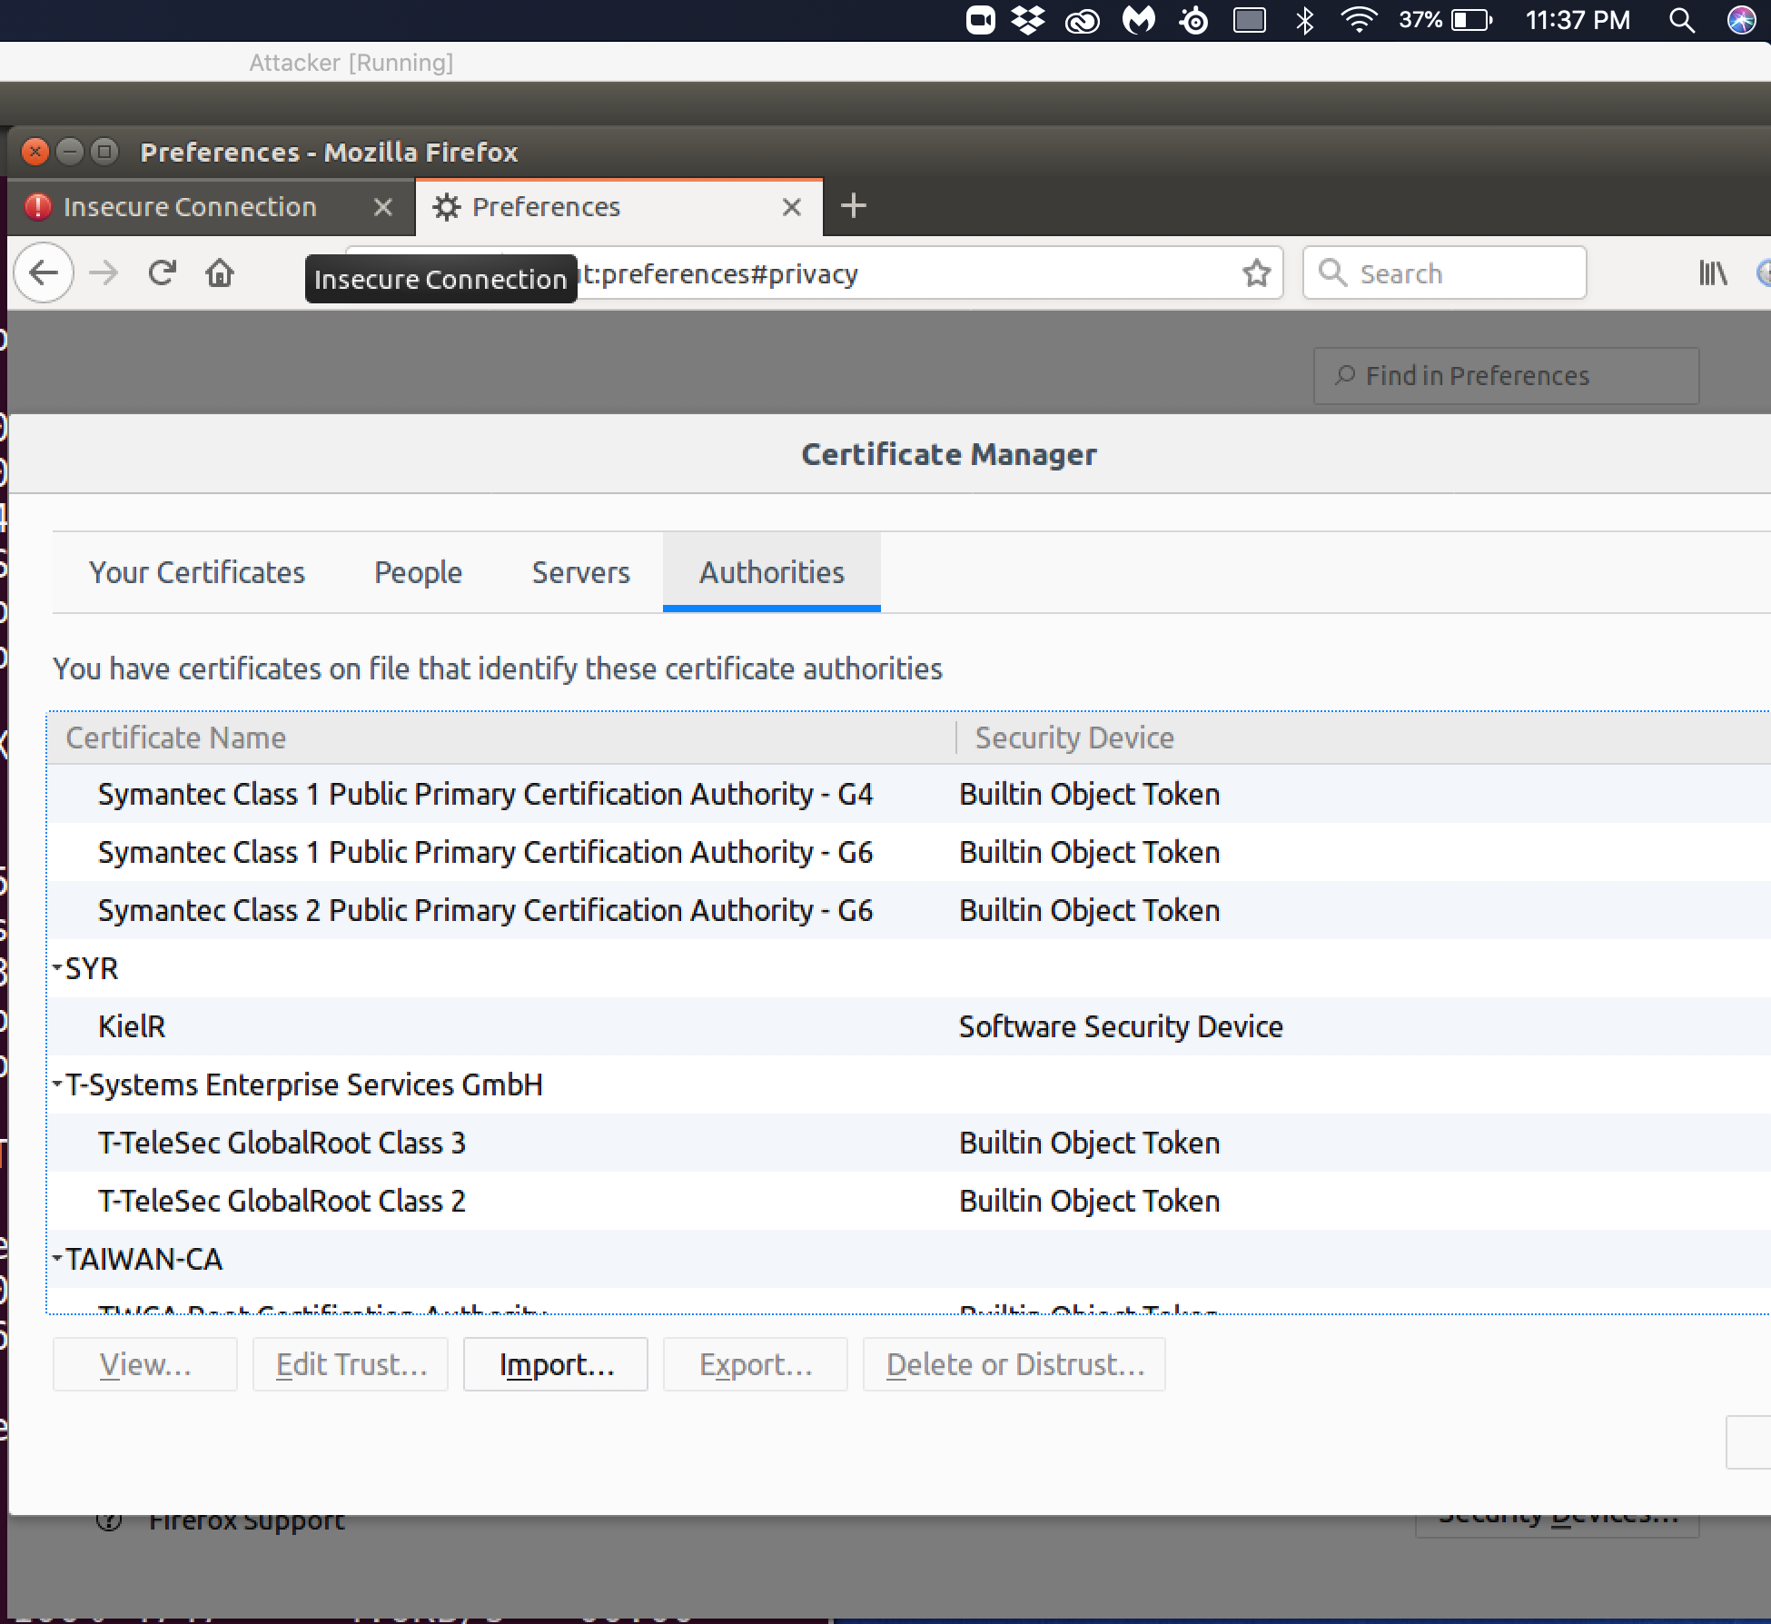

Observation: The above screenshot shows our root certificate authority cert added to the certificate manager in the authorities' tab.

Explanation: The manually added certificate with “KielR” as the trusted certificate authority in the Firefox browser certificate manager. Therefore, when the firefox browser checks a certificate issued by “KielR” our manually added certificate authority will be seen as a trusted certificate issuer. This allows the ability to connect to the website using the certificate that I have generated with myself as the CA.

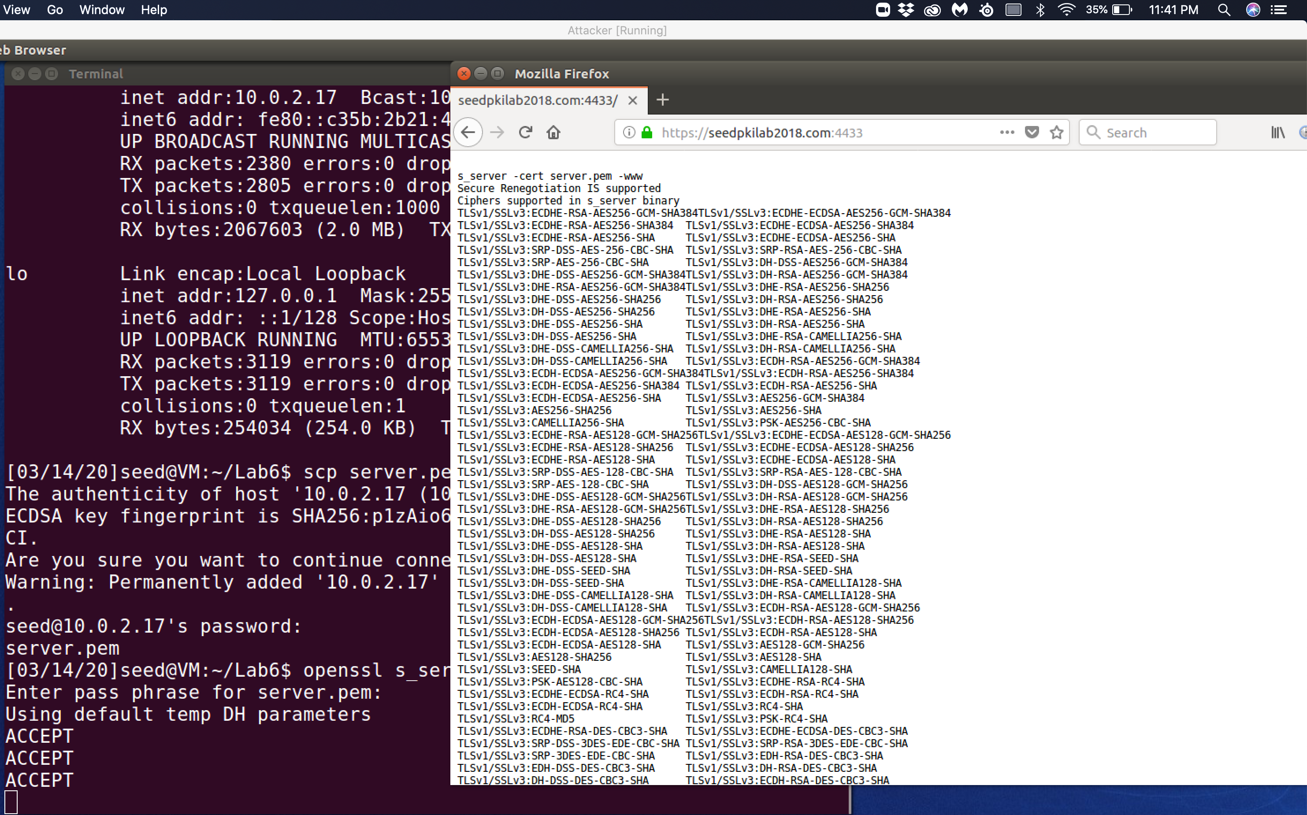

Observation: The above screenshot shows that the website now successfully loads because the Firefox browser trusts the generated certificate.

Explanation: The above screenshot shows that the Firefox browser verified in its certificate manager through the Certificate authorities and found our manually added CA. The website connection is viewed as secure enabling our browser to connect to the site. This connection to the site through the HTTPS protocol that utilizes the public key from the certificate to encrypt all communications between the host of the website and the Firefox browser user.

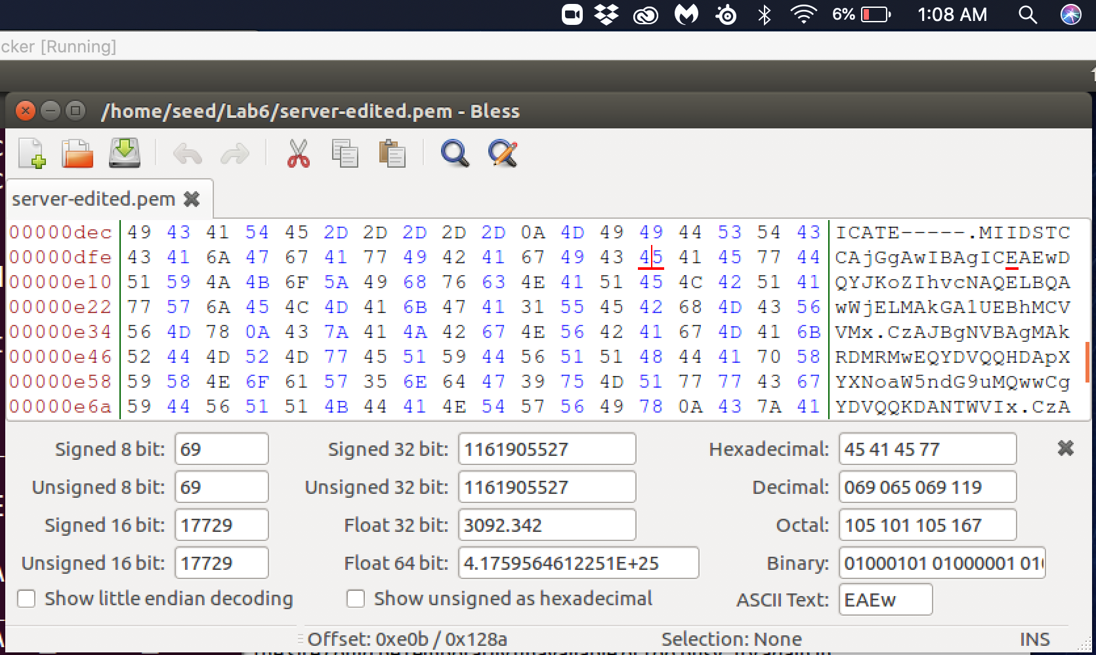

Observation: This is a copy of the server.pem file that has been copied before it has been changed to add in an error. The error was introduced in the dfe row to changed the value from 45 to 46 show in the screenshot below.

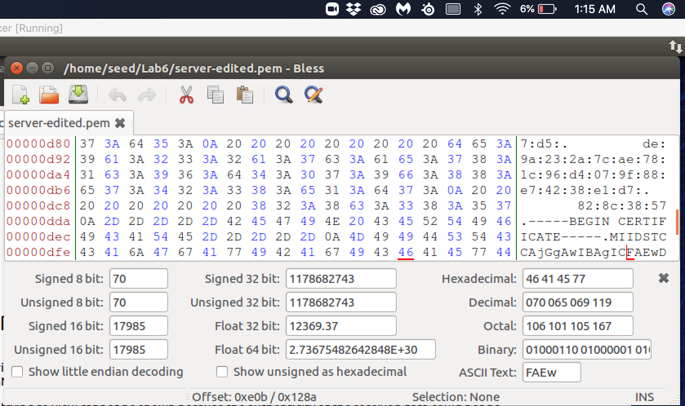

Observation: The above screenshot shows the value of the .pem file changed from 45 to 46.

Explanation: The change in that byte has been corrupted and this will change the signature of the certificate. This makes the signature invalid because when the signature is validated the will be a difference when the two signatures are compared. This will make the connection invalid and the Firefox browser fails when trying to create the secure connection.

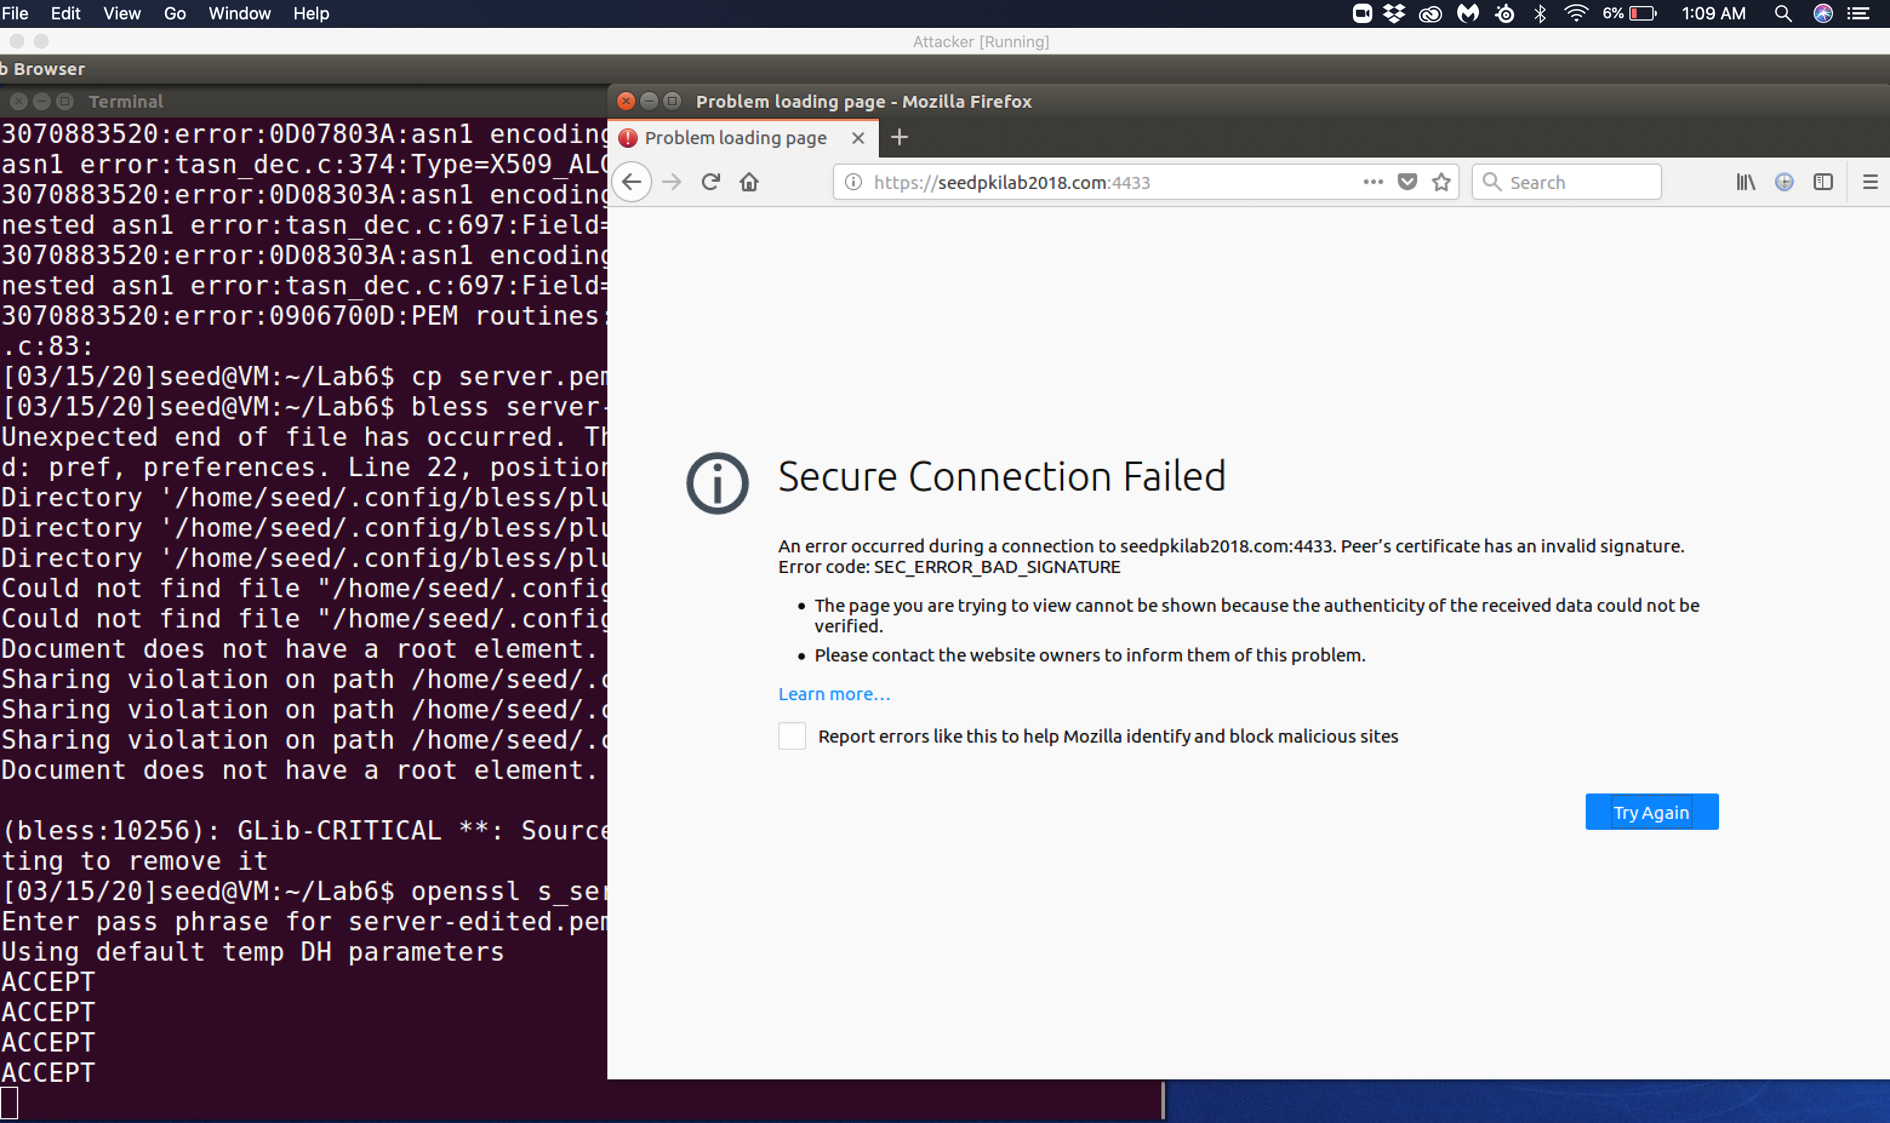

Observation: The above screenshot shows the error in the connection occured during the connection to the seedpkilab2018 on port 4433. That the peer’s certificate has an invalid signature. The errorcode is SEC_ERROR_BAD_SIGNATURE.

Explanation: The peer certificate has been altered from the verified version from the corrupted byte in the edited signature. This corrupted signature no longer passes the check that is used to ensure that the signature hasn’t been altered. This makes the Firefox Browser throwing an error when trying to verify the signature that results in the connection fail.

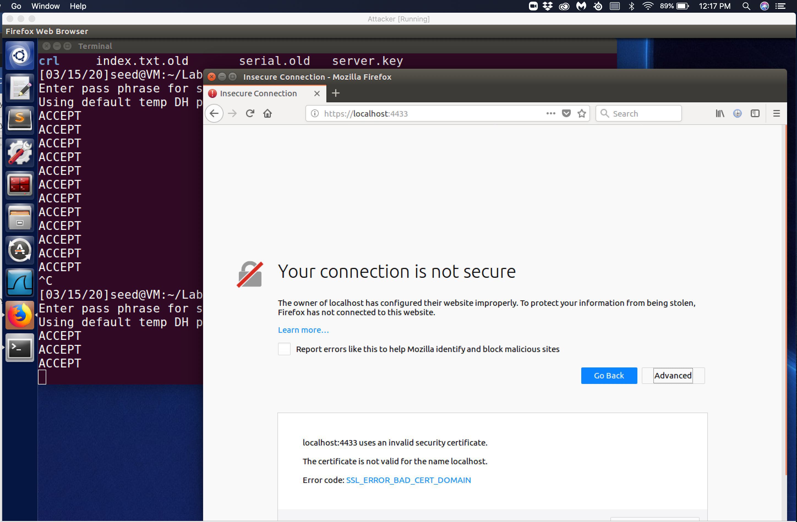

Observation: I then try to connect to the website using localhost. The connection fails because the because the certificate is seen as invalid since the certificate was not issued for the name localhost. This throws the certificate error code SSL_ERROR_BAD_CERT_DOMAIN

Explanation: This attempted connection to the localhost identifies the need to ensure that the website I am trying to connect to is identified in the common field name. I generated a valid certificate for the website SEEDPKILab2018.com site but when the Firefox browser resolved the site name with the common field name identified in the browser that it differed from the site attempting to be accessed localhost and the site the certificate was generated for SEEDPKILab2018.com. This is a demostration of the importance of resolving the common name of the generated certificate and the site request. In the case of a malicious website that attempts to use a valid certificate that is being used for a site with a different common name. The user must verify the common name is the same as the site the user is trying to use the certificate. In the case that the malicious website is attempting to use the real websites certificate but the malicious site doesn’t have the private key so any encryption checks would fail.

Task 4:

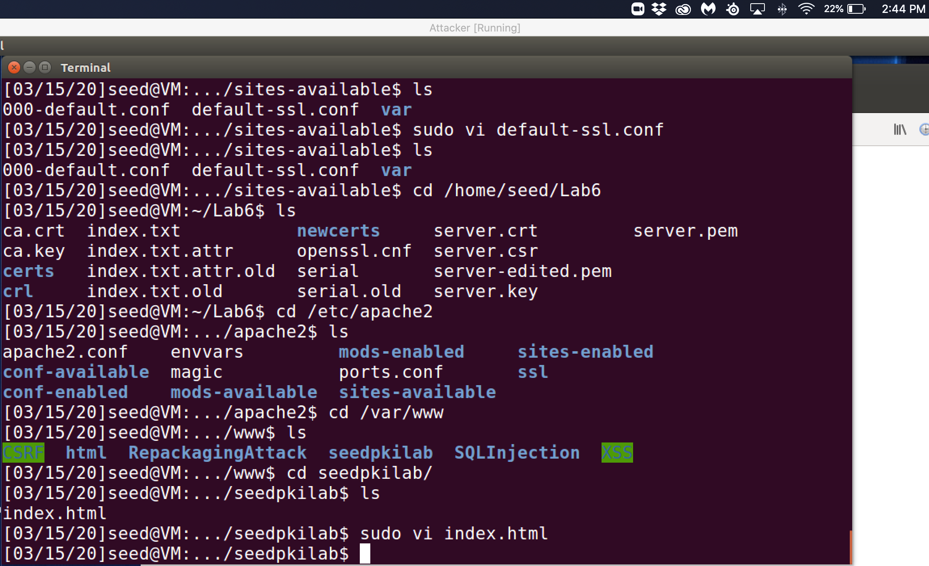

Observation: The above screenshot is the file structure to enable the site information to be displayed.

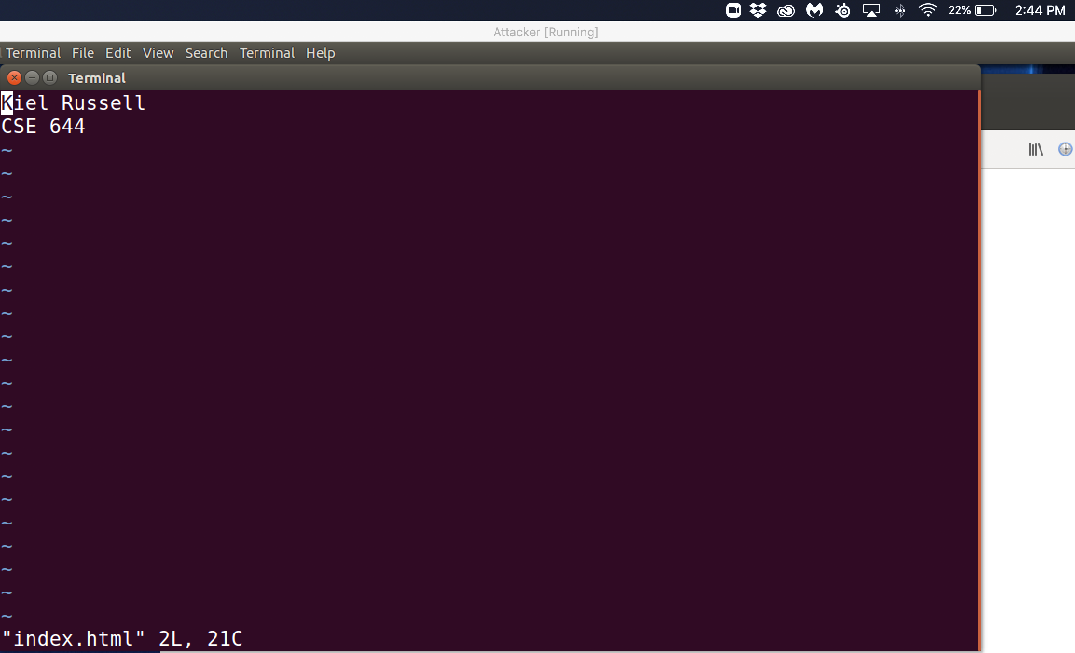

Observation: The index.html file is what will be displayed when accessing the seedpkilab2018.com site.

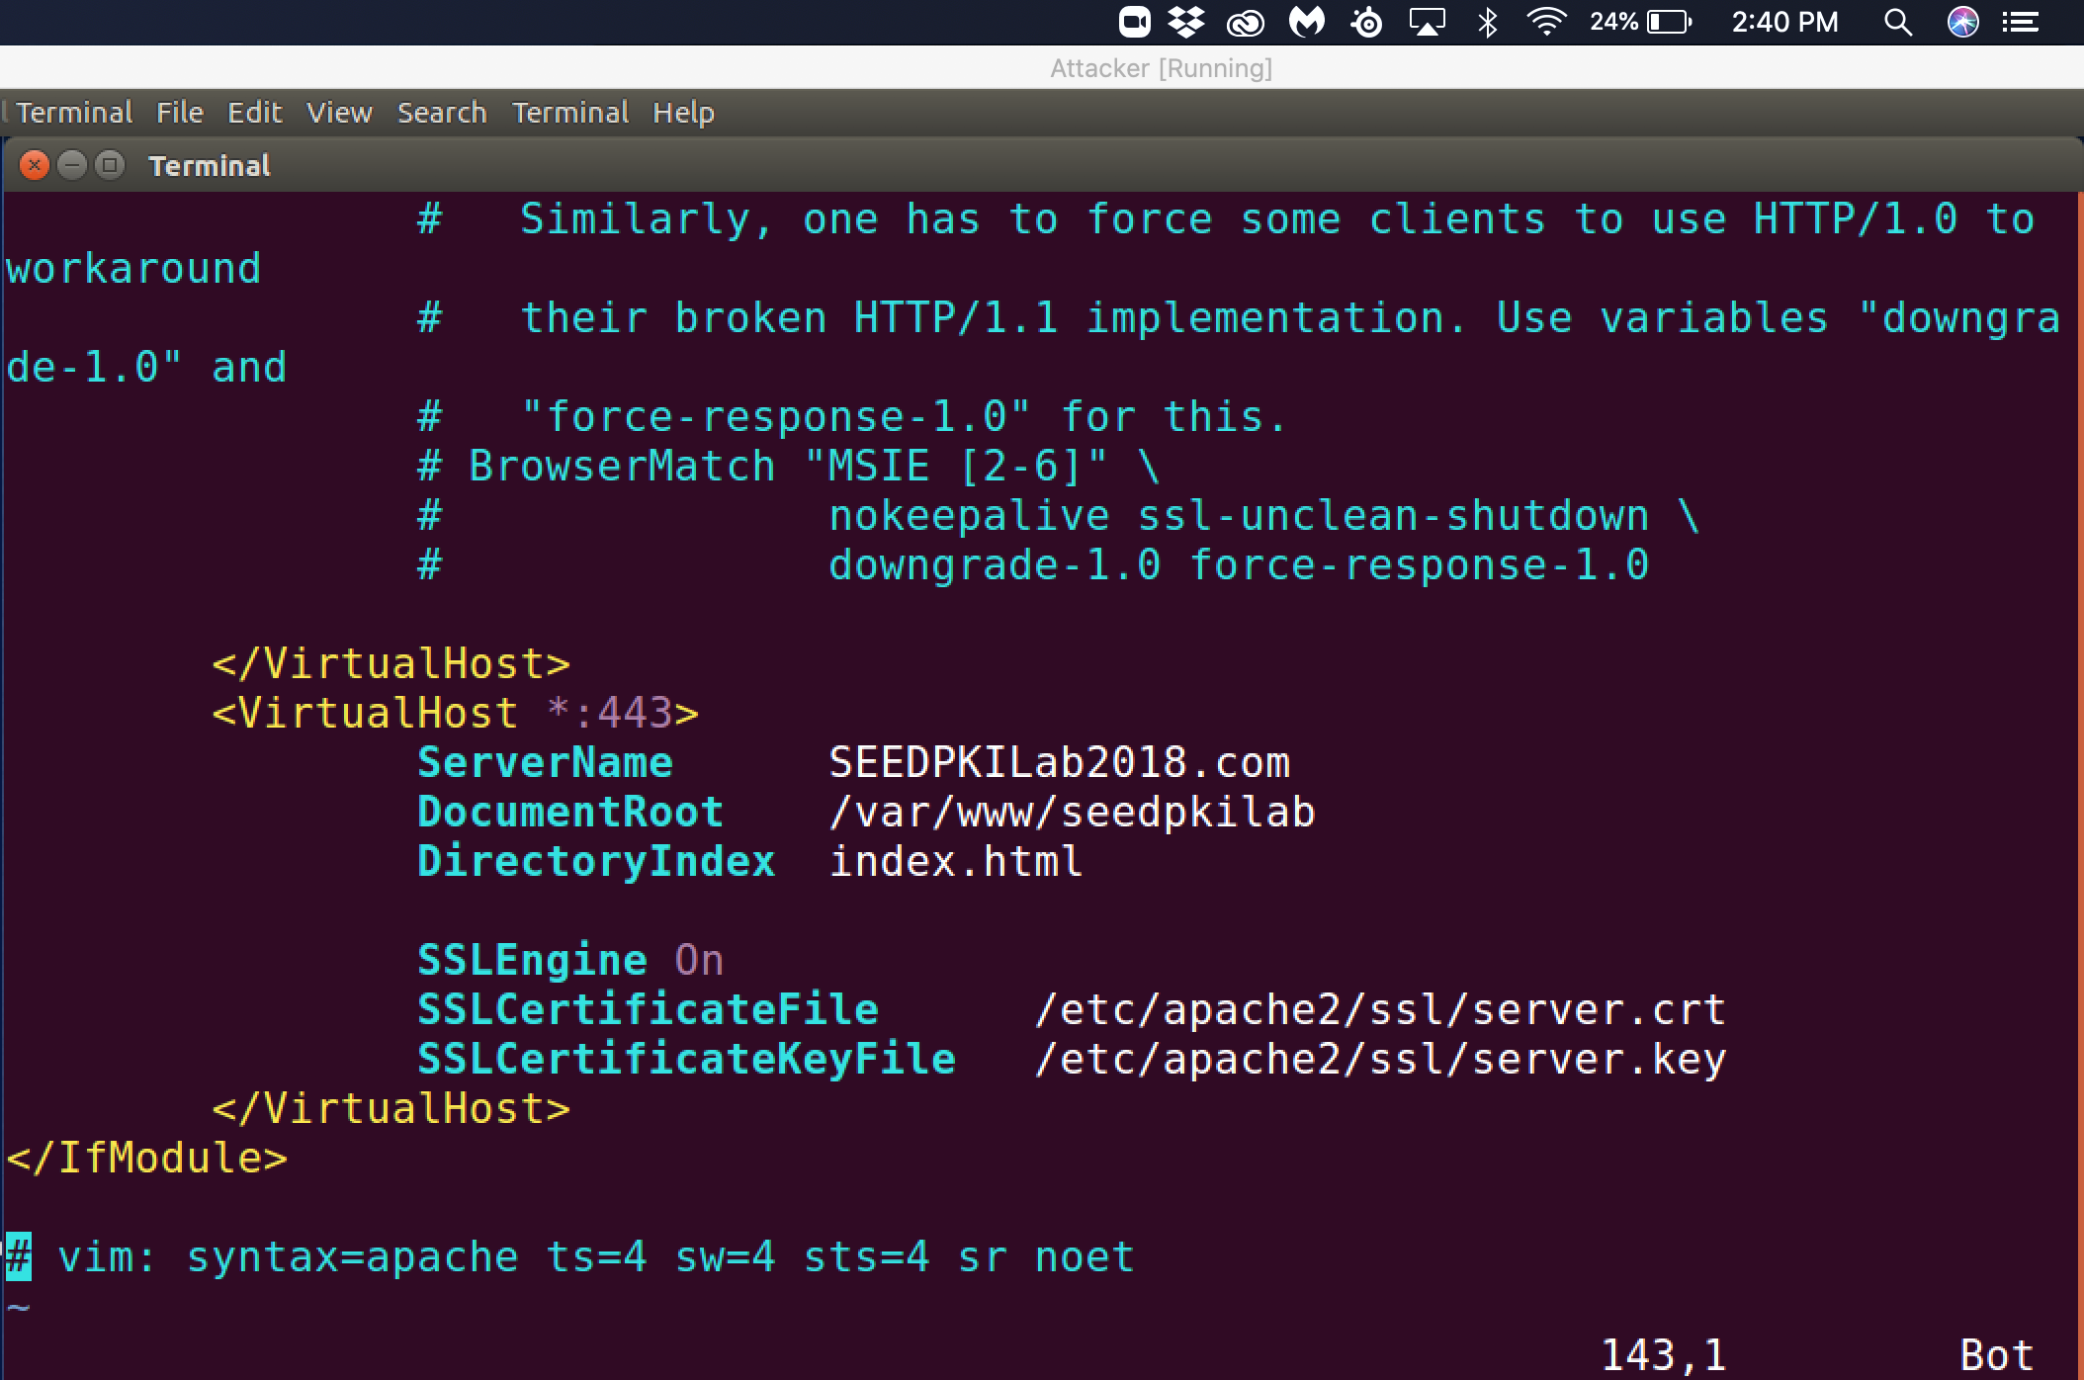

Observation: This is the entry for the SEEDPKILab2018.com that is added to the default-ssl.conf file.

Explanation: This entry is needed for our testing site that will be the default ssl configuration file. This enables our test site to be added to the list of websites that the apache2 server supports and hosts. The port that this communicates on is 443 because we are accessing the site through the https protocol with ssl enabled. Our ServerName is SEEDPKILab2018.com. The DocumentRoot is in the /var/www/seedpkilab that contains the text that is displayed in the index.html site. This DirectoryIndex is the html file that serves the purpose of being the front end of the site we are running. I created a website that displays my name and the class. The SSL engine is turned on and I had to provide the path to the server.crt file and the server.key file as well create the ssl folder to store them in. This will inform the apache server where to locate the file to verify this is a valid website.

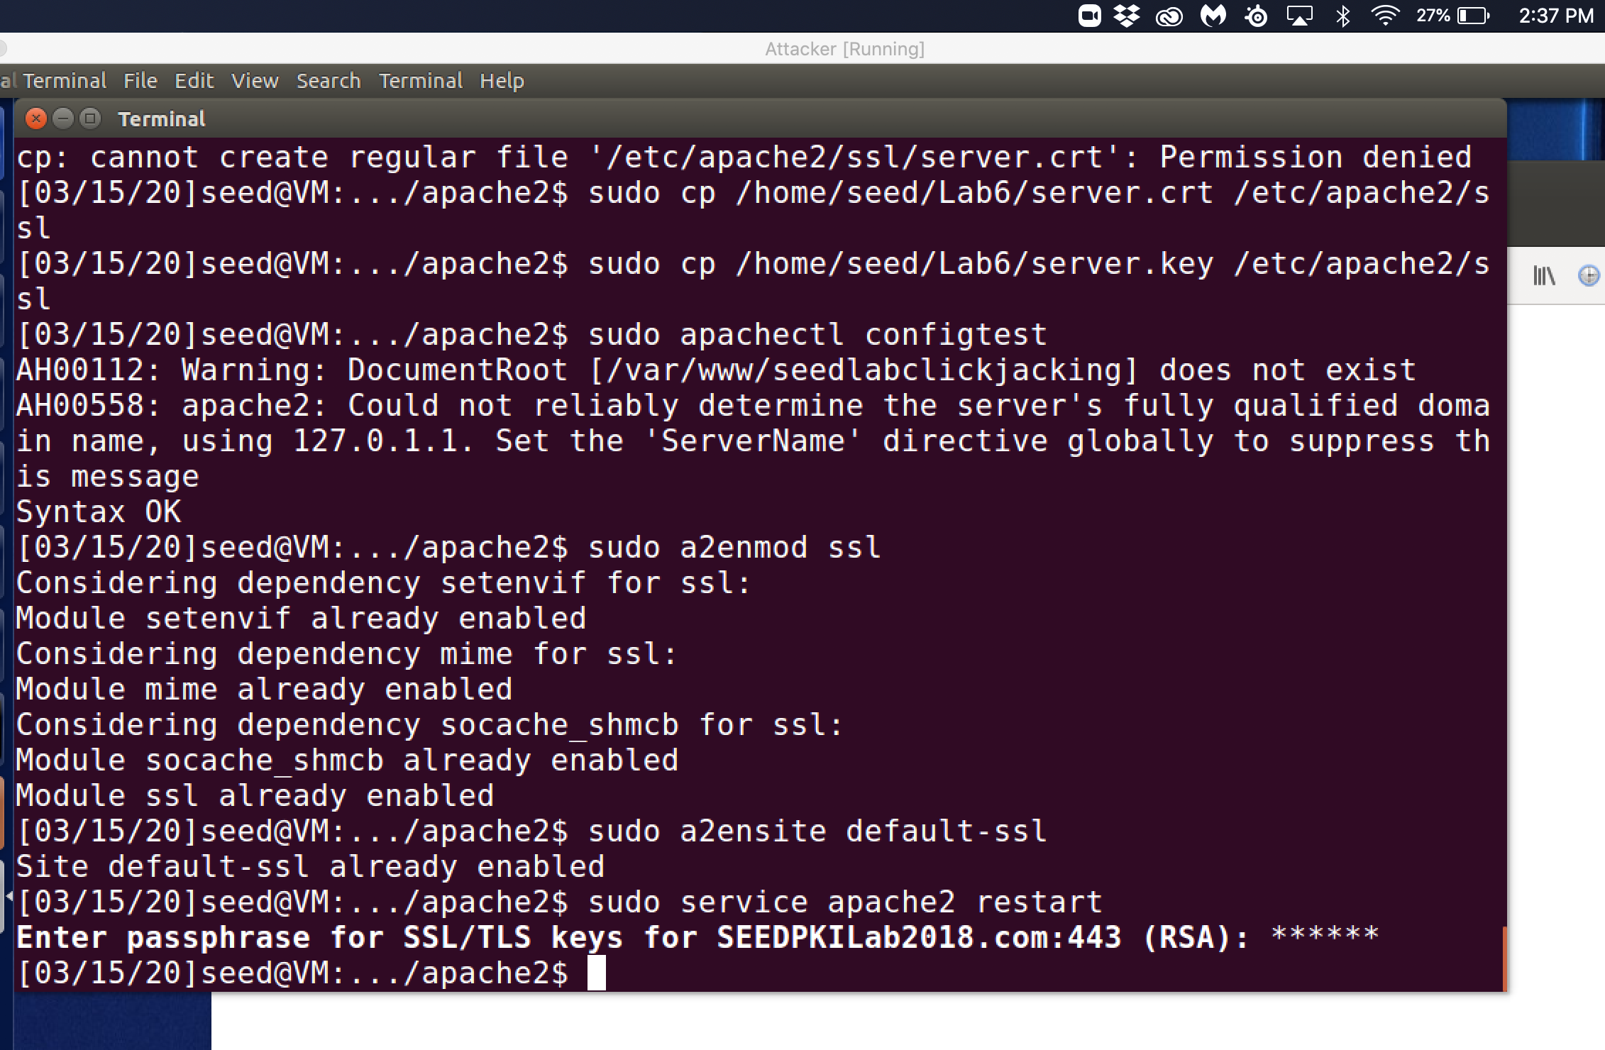

Observation: The commands used are sudo apachectl configtest, sudo a2enmod ssl, sudo a2ensite default-ssl, and then sudo apache restart.

Explanation: The sudo apachectl configtest command will check for any errors in the config files which I was initially having issues with but when I noticed that the ssl in the apache2 folder was just a certificate file. I deleted it and with mkdir created a ssl folder then copied server.crt and server.key into that folder. When I finished this all config checks succeeded. The sudo a2enmode ssl command enables the use of the SSL module. This enforces the use of SSL encryption for our site through the apache web server to keep our website communications secure. sudo a2ensite default-ssl enables the website and checks the entries in the default-ssl.conf file to use the new entry we put in for our website. I then used sudo service apache2 restart to ensure that all of our changes are updated. This then asks for a passphrase for my site, which I used turing as the pass phrase.

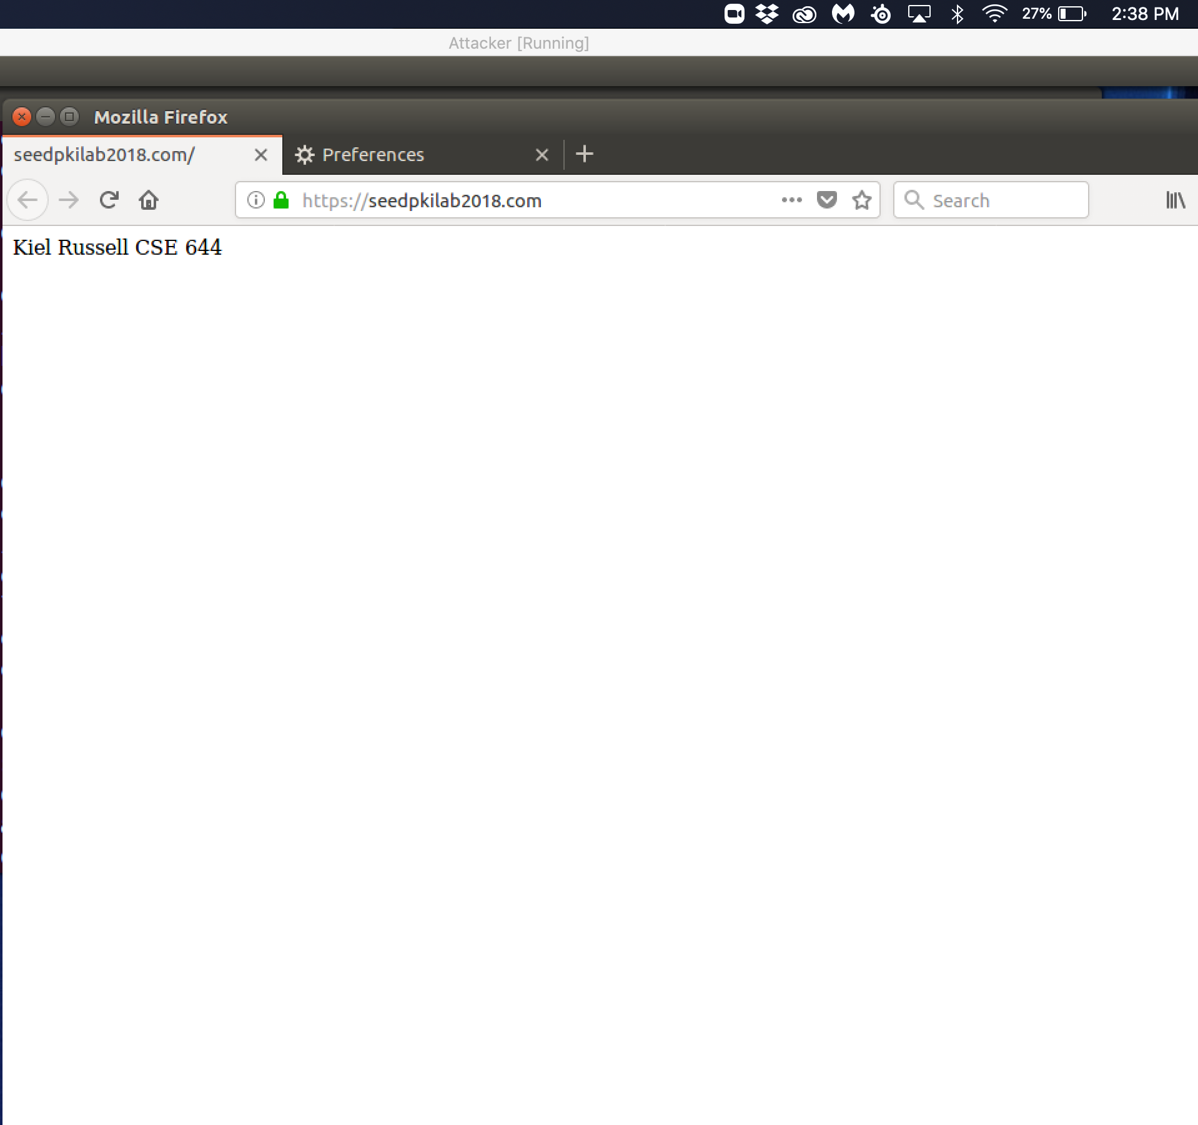

Observation:The data that I put into the index.html file is displayed through the browser when I go to the website that was setup for this lab.

Explanation: The <https://seedpkilab2018.com> is using our generated certificate that is utilized when entering the openssl command. The website is successfully able to be accessed because we have installed our certificate as a CA in the browser’s authorities store. Therefore, the Firefox browser treats our website as an authentic one. This connection is using https ssl encryption to make sure that all traffic to and from the site is encrypted.